Yes. For students, the explanation should be simple, practical, and interview-oriented. I also recommend showing a sample dashboard/output image for each module so they can understand what they are building.
Below is a teaching-friendly explanation.

1. Vendor Management
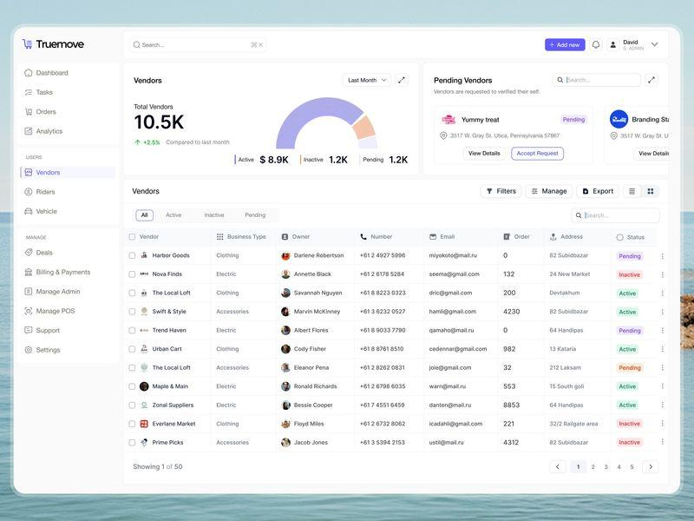
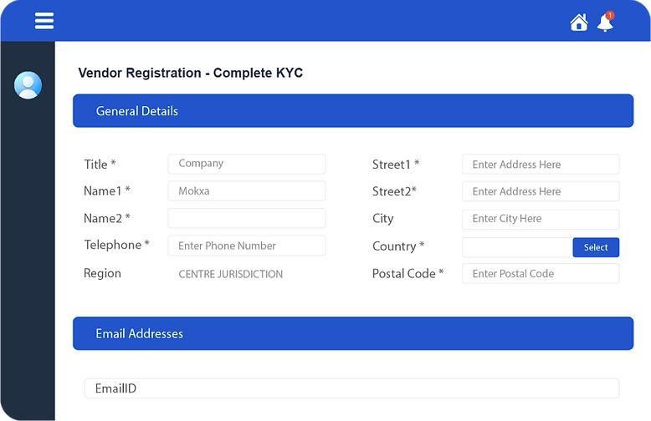
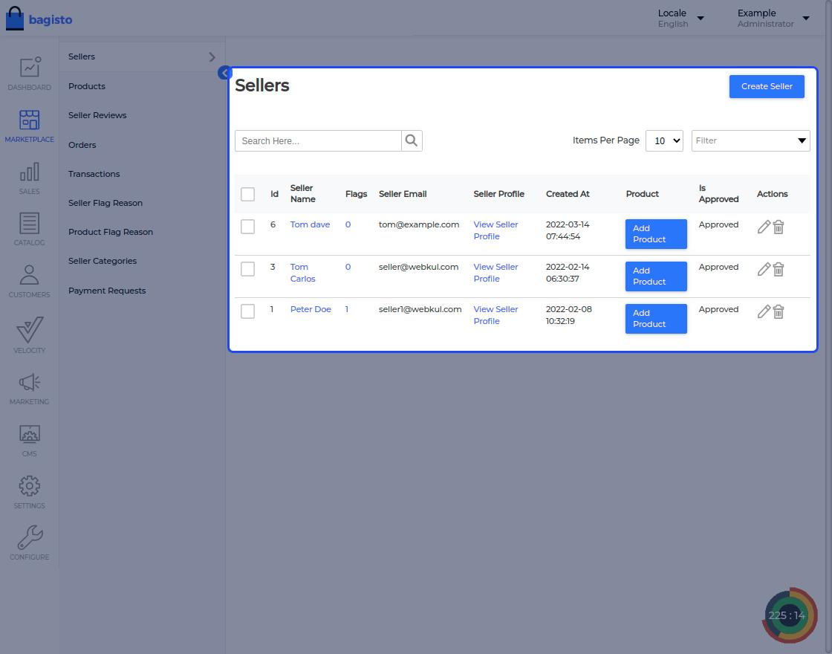
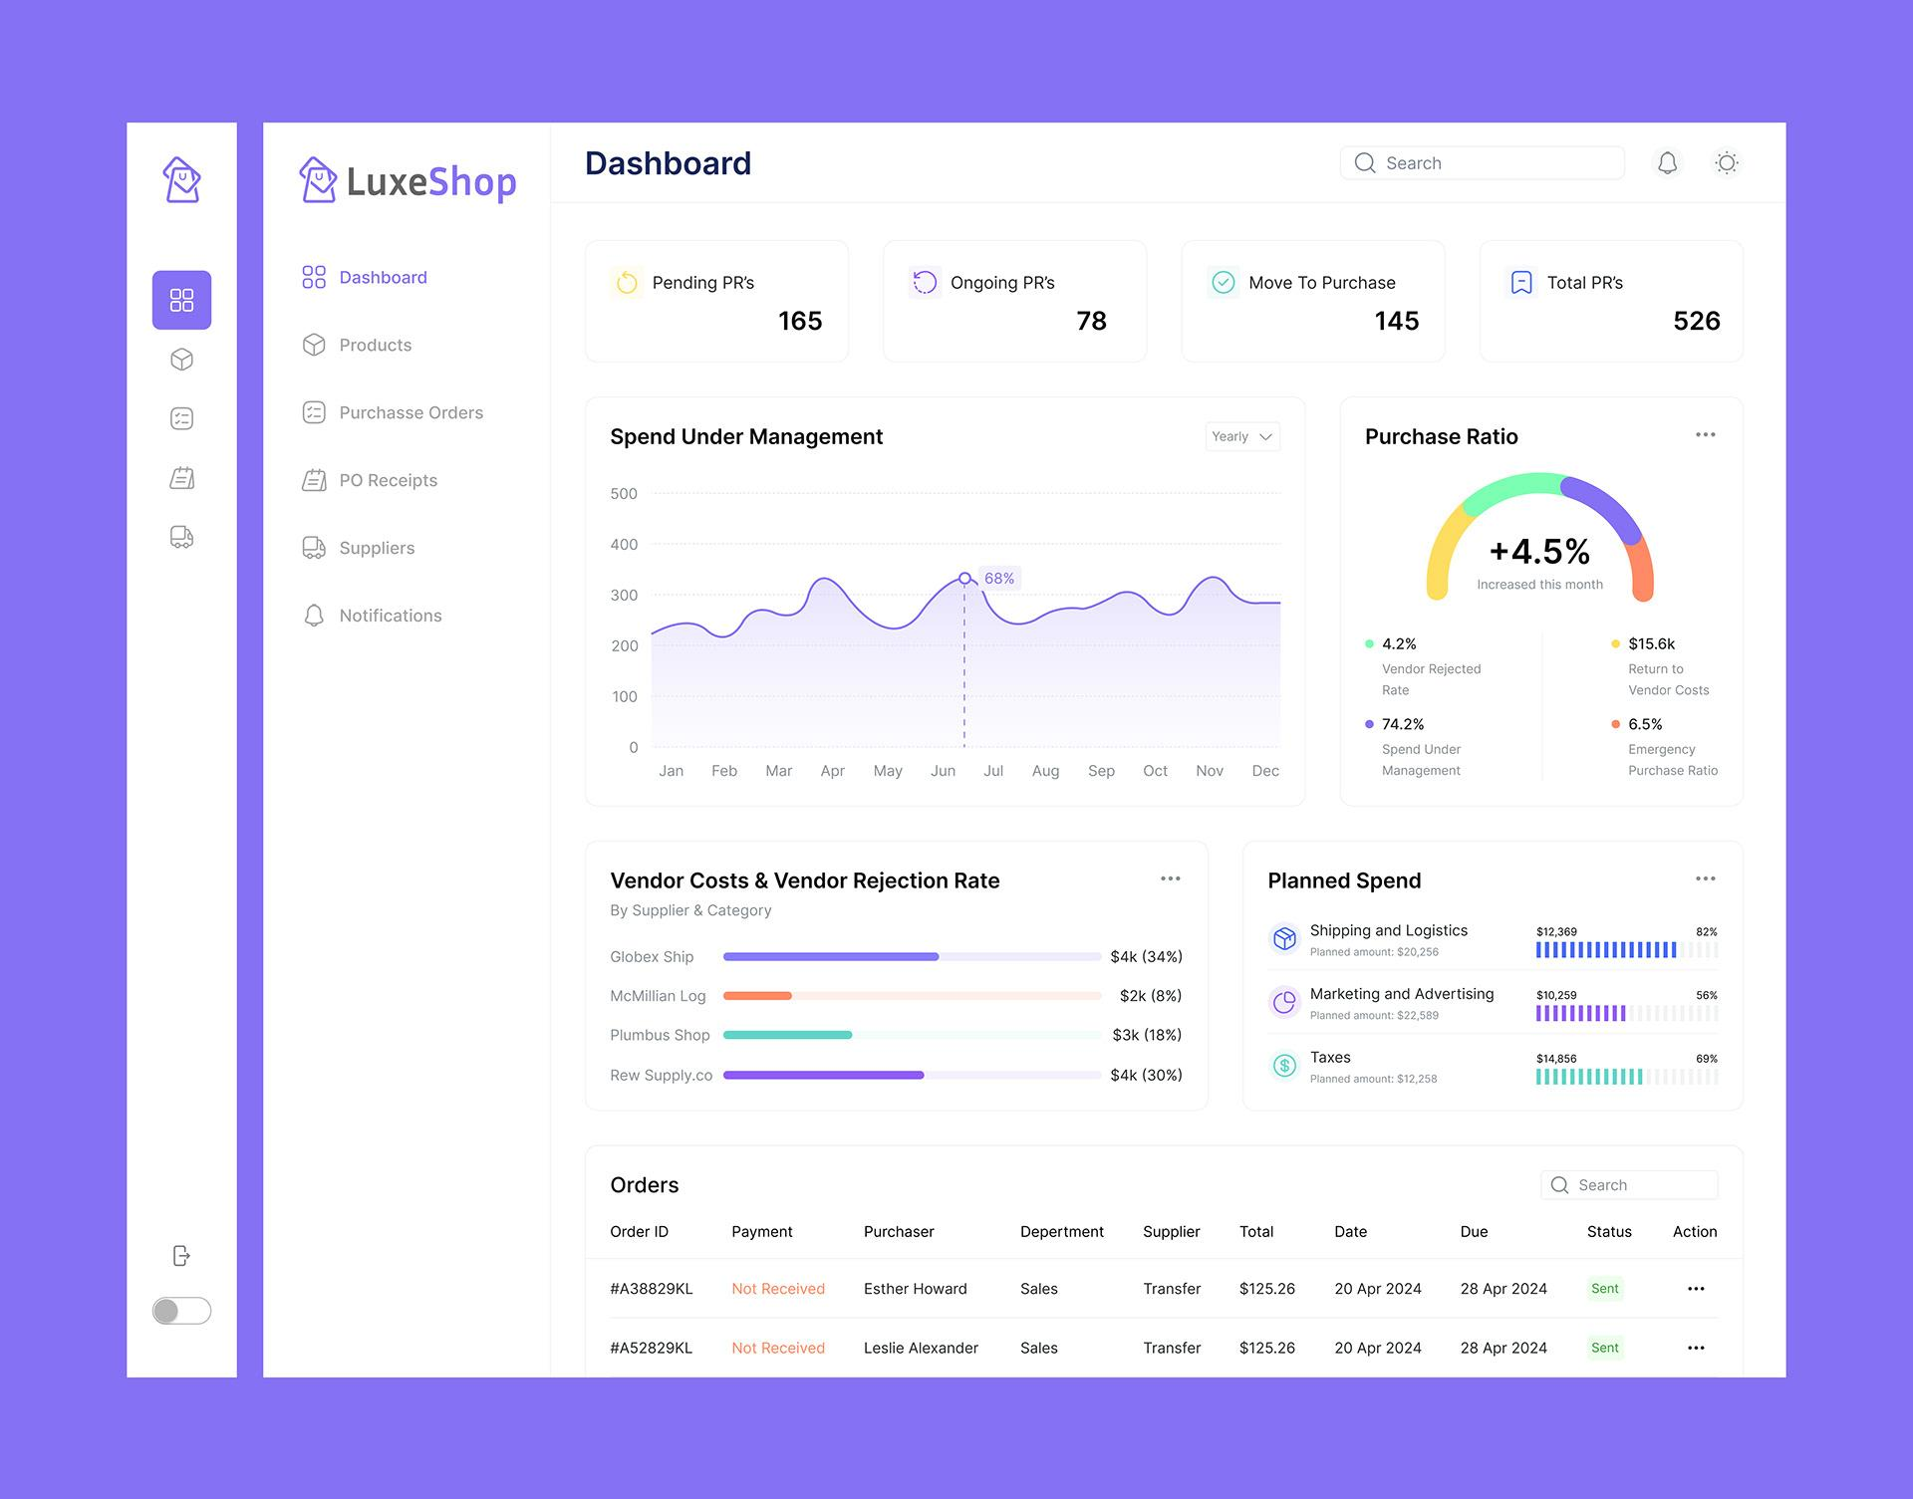
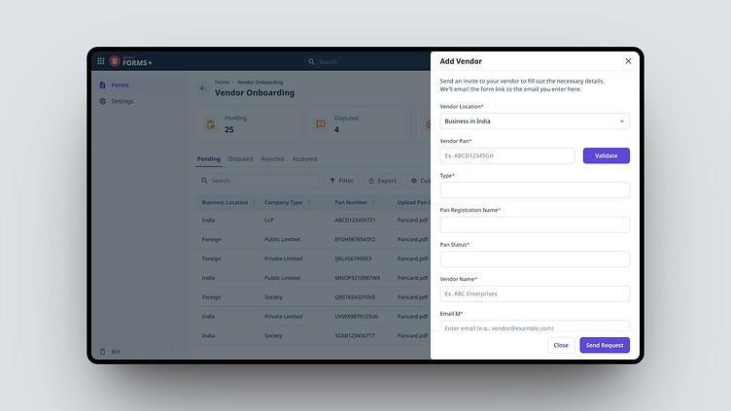
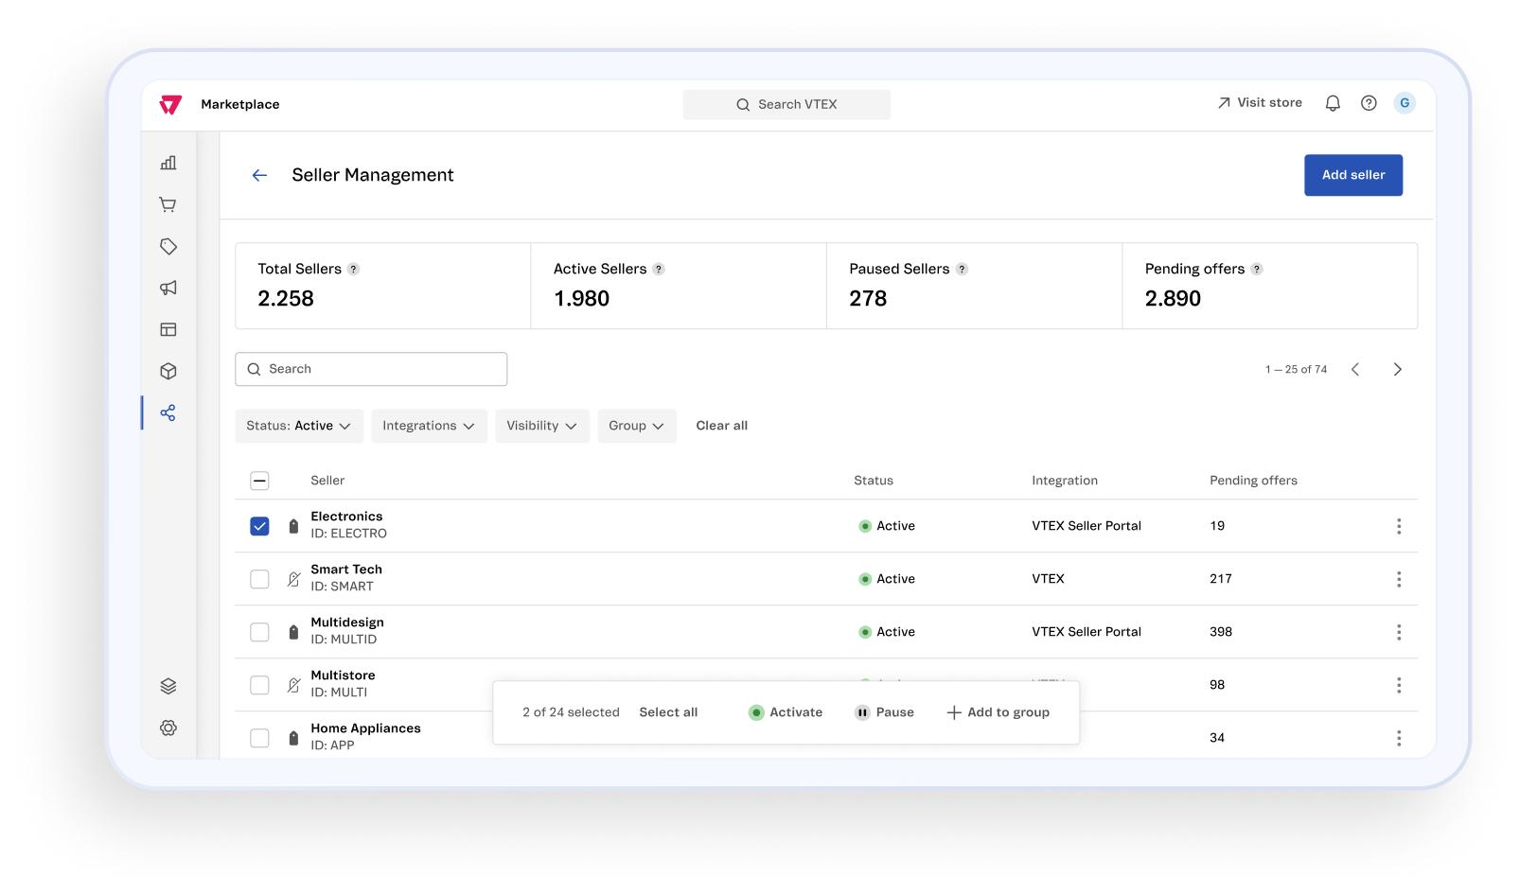

What is Vendor Management?
A Vendor is a seller who sells products on an online marketplace.
Examples:
- Amazon Seller
- Flipkart Seller
- Meesho Seller
One marketplace contains thousands of vendors.
Instead of managing products manually, the system manages vendors automatically.

What does Vendor Management do?
- Vendor Registration
- Vendor Login
- Vendor Verification
- Vendor Approval
- Product Upload
- Vendor Status (Active / Inactive)
- Commission Management

Example
Vendor Name
ABC Electronics

Products
Laptop
Mouse
Keyboard

Status
Verified

Commission
8%

2. Marketplace Management
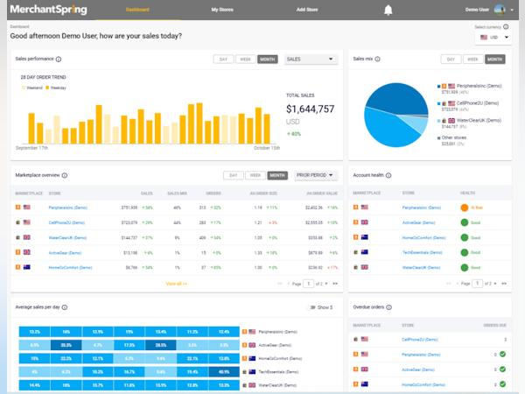
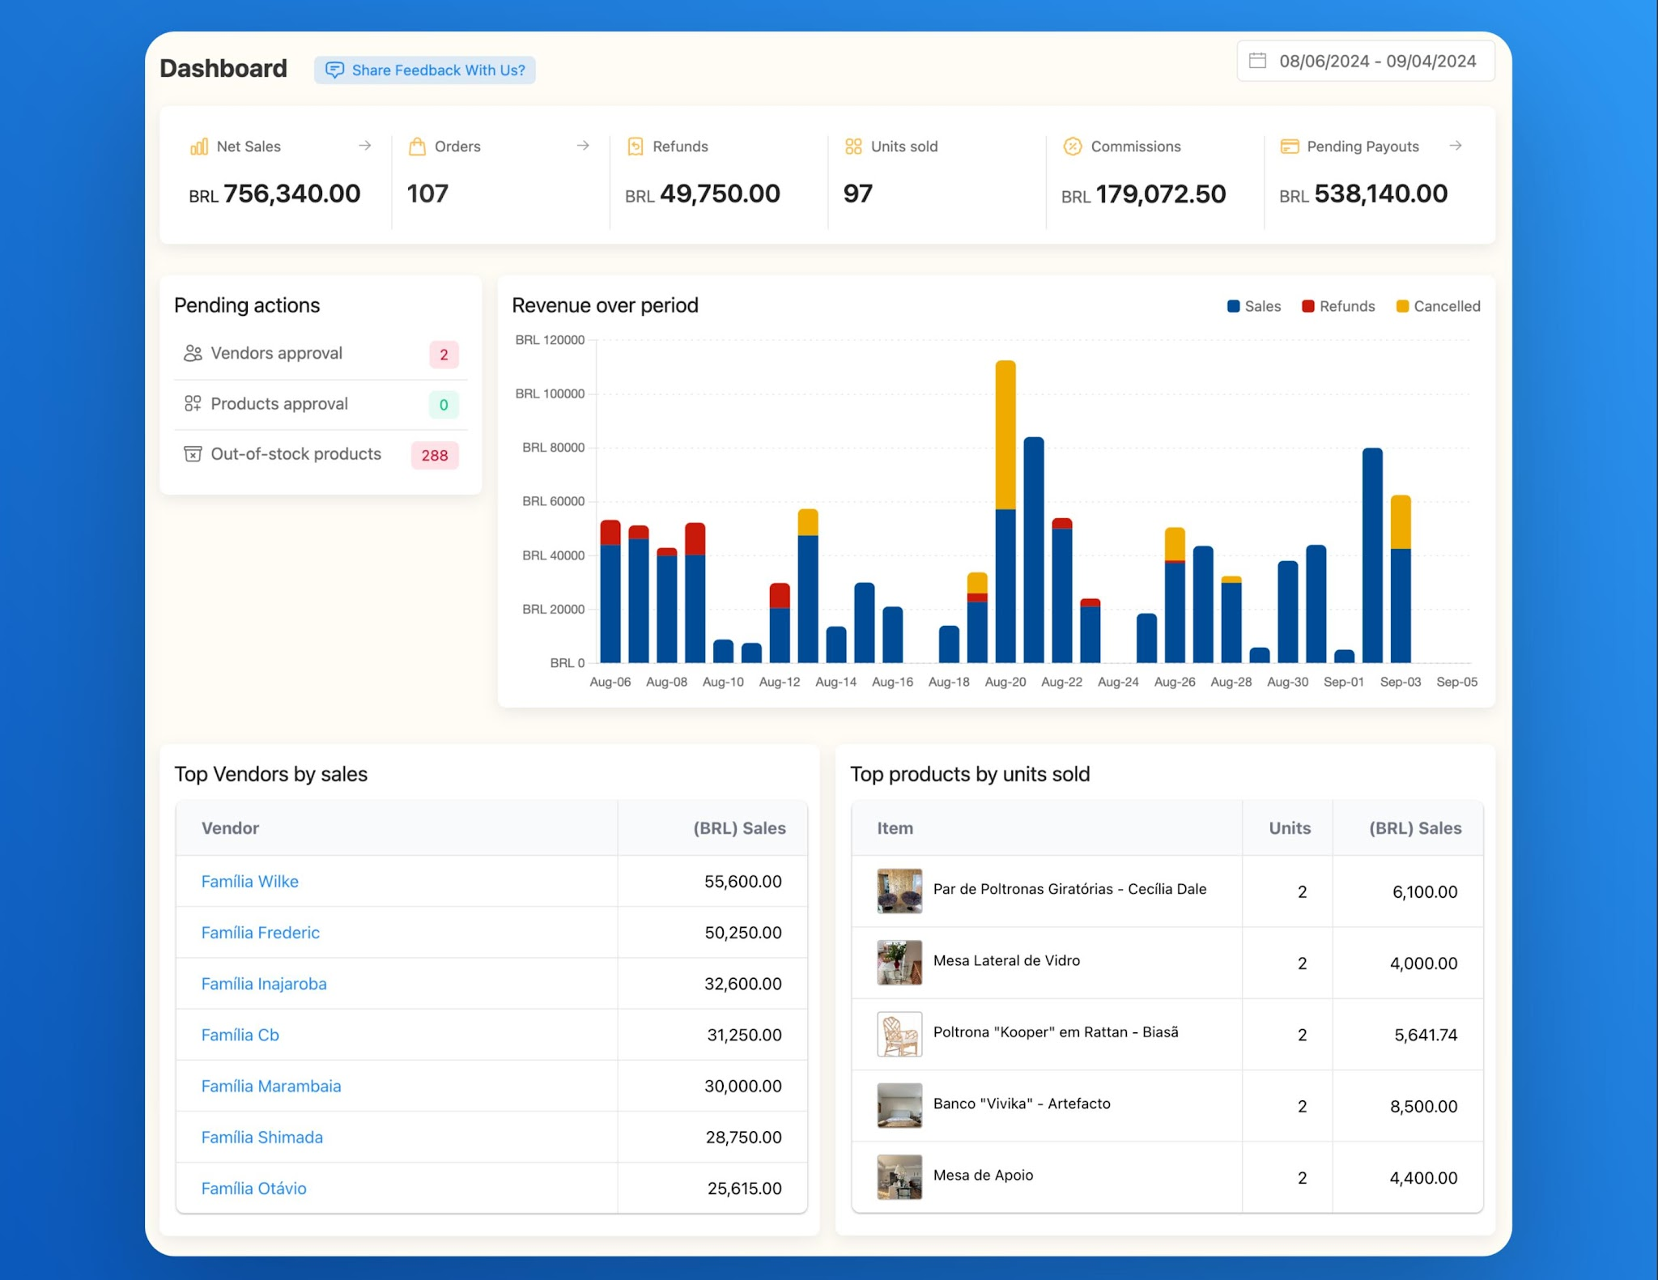
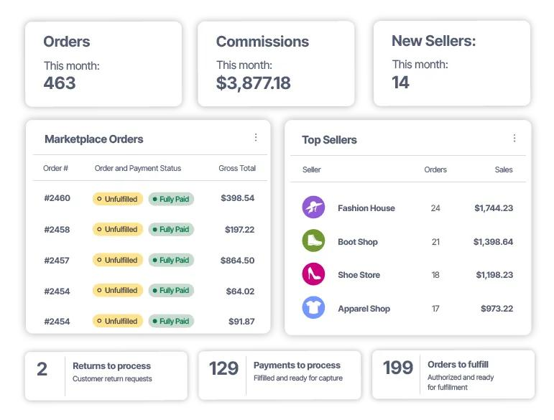
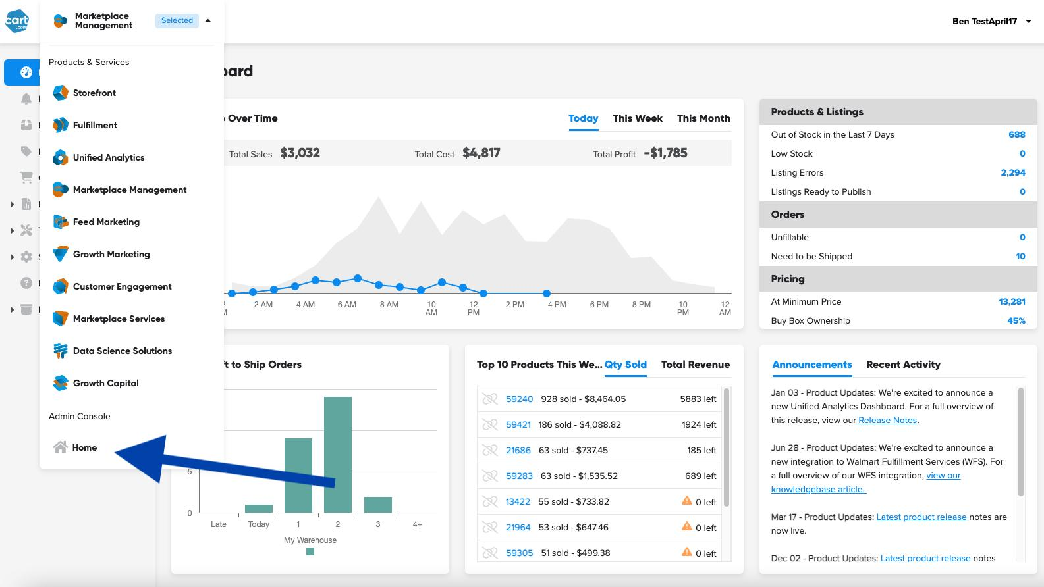
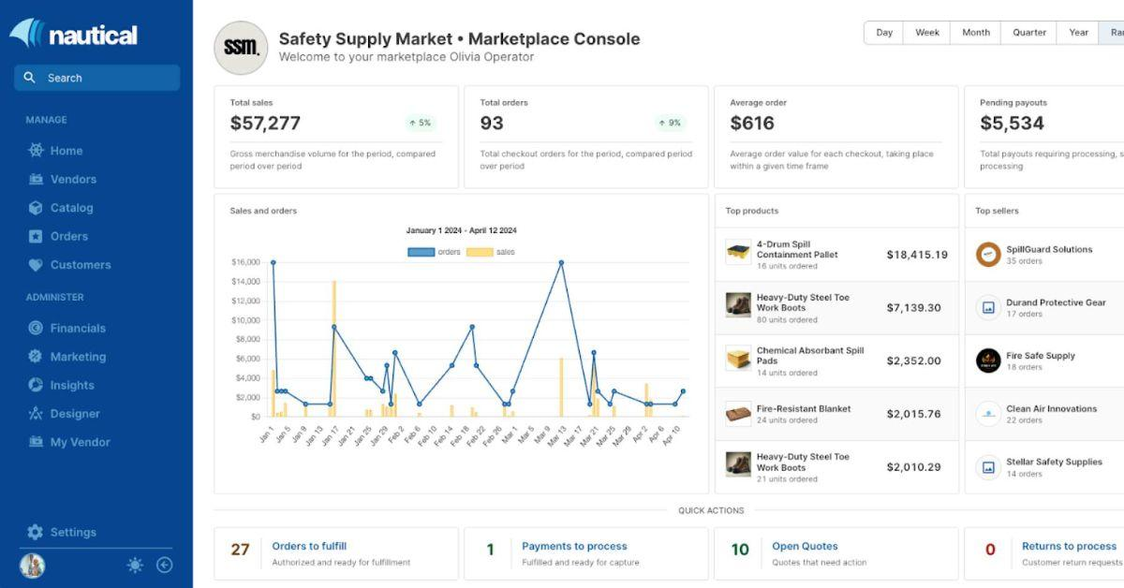
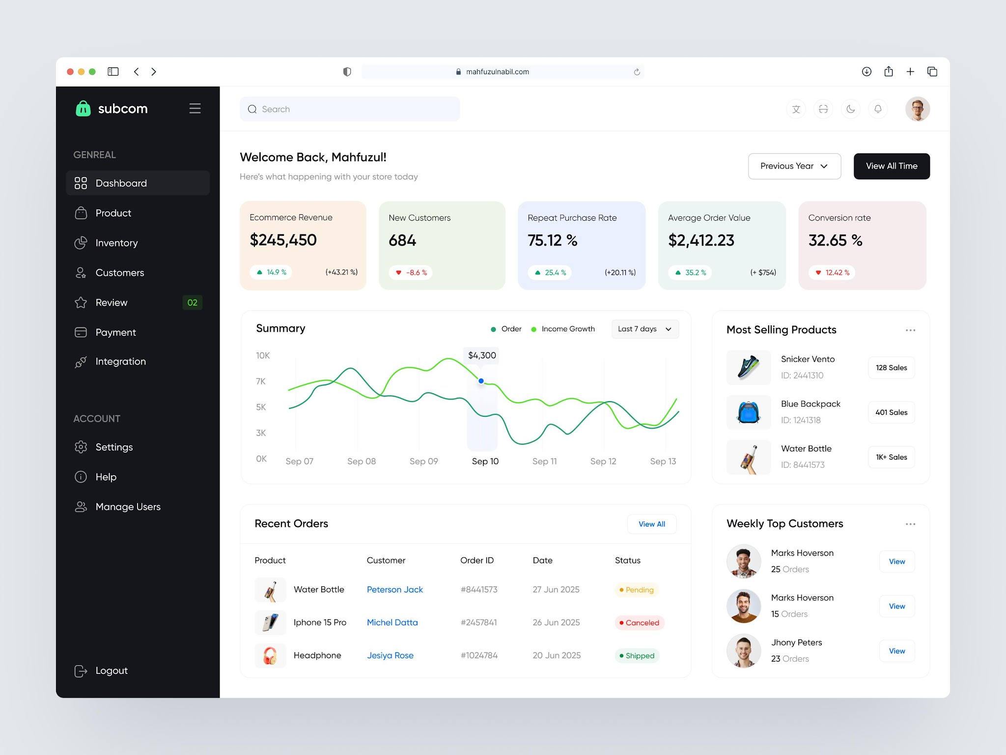

What is Marketplace Management?
Marketplace means a website where many vendors sell products.
Example
Amazon

↓

Seller A
Seller B
Seller C

↓

Customers purchase products

Administrator can
- Add Vendors
- Remove Vendors
- Manage Products
- View Orders
- View Payments
- View Revenue

Example Output
Total Vendors : 245

Products : 12,000

Orders Today : 980

Revenue : $45,000

3. Inventory Analytics
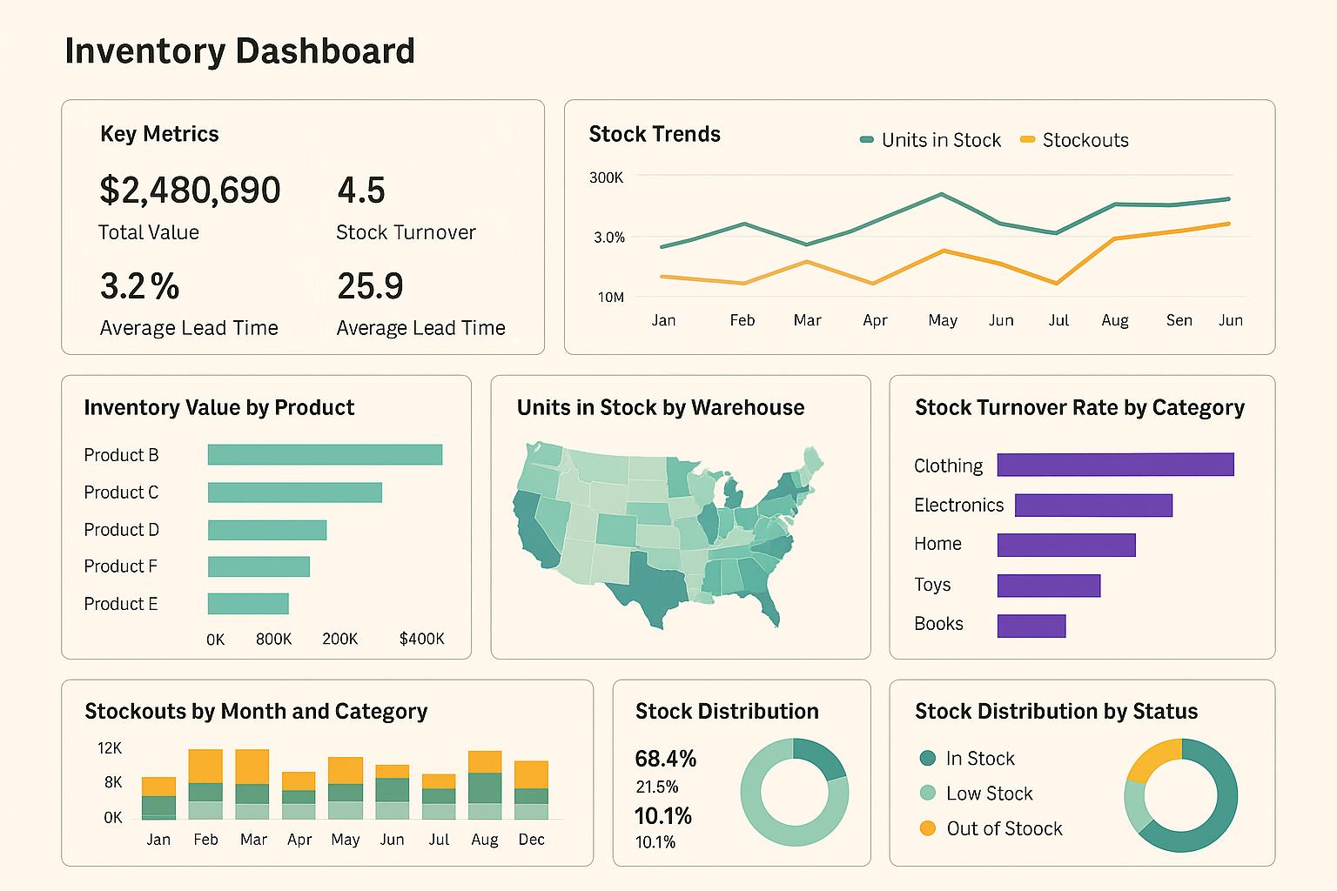
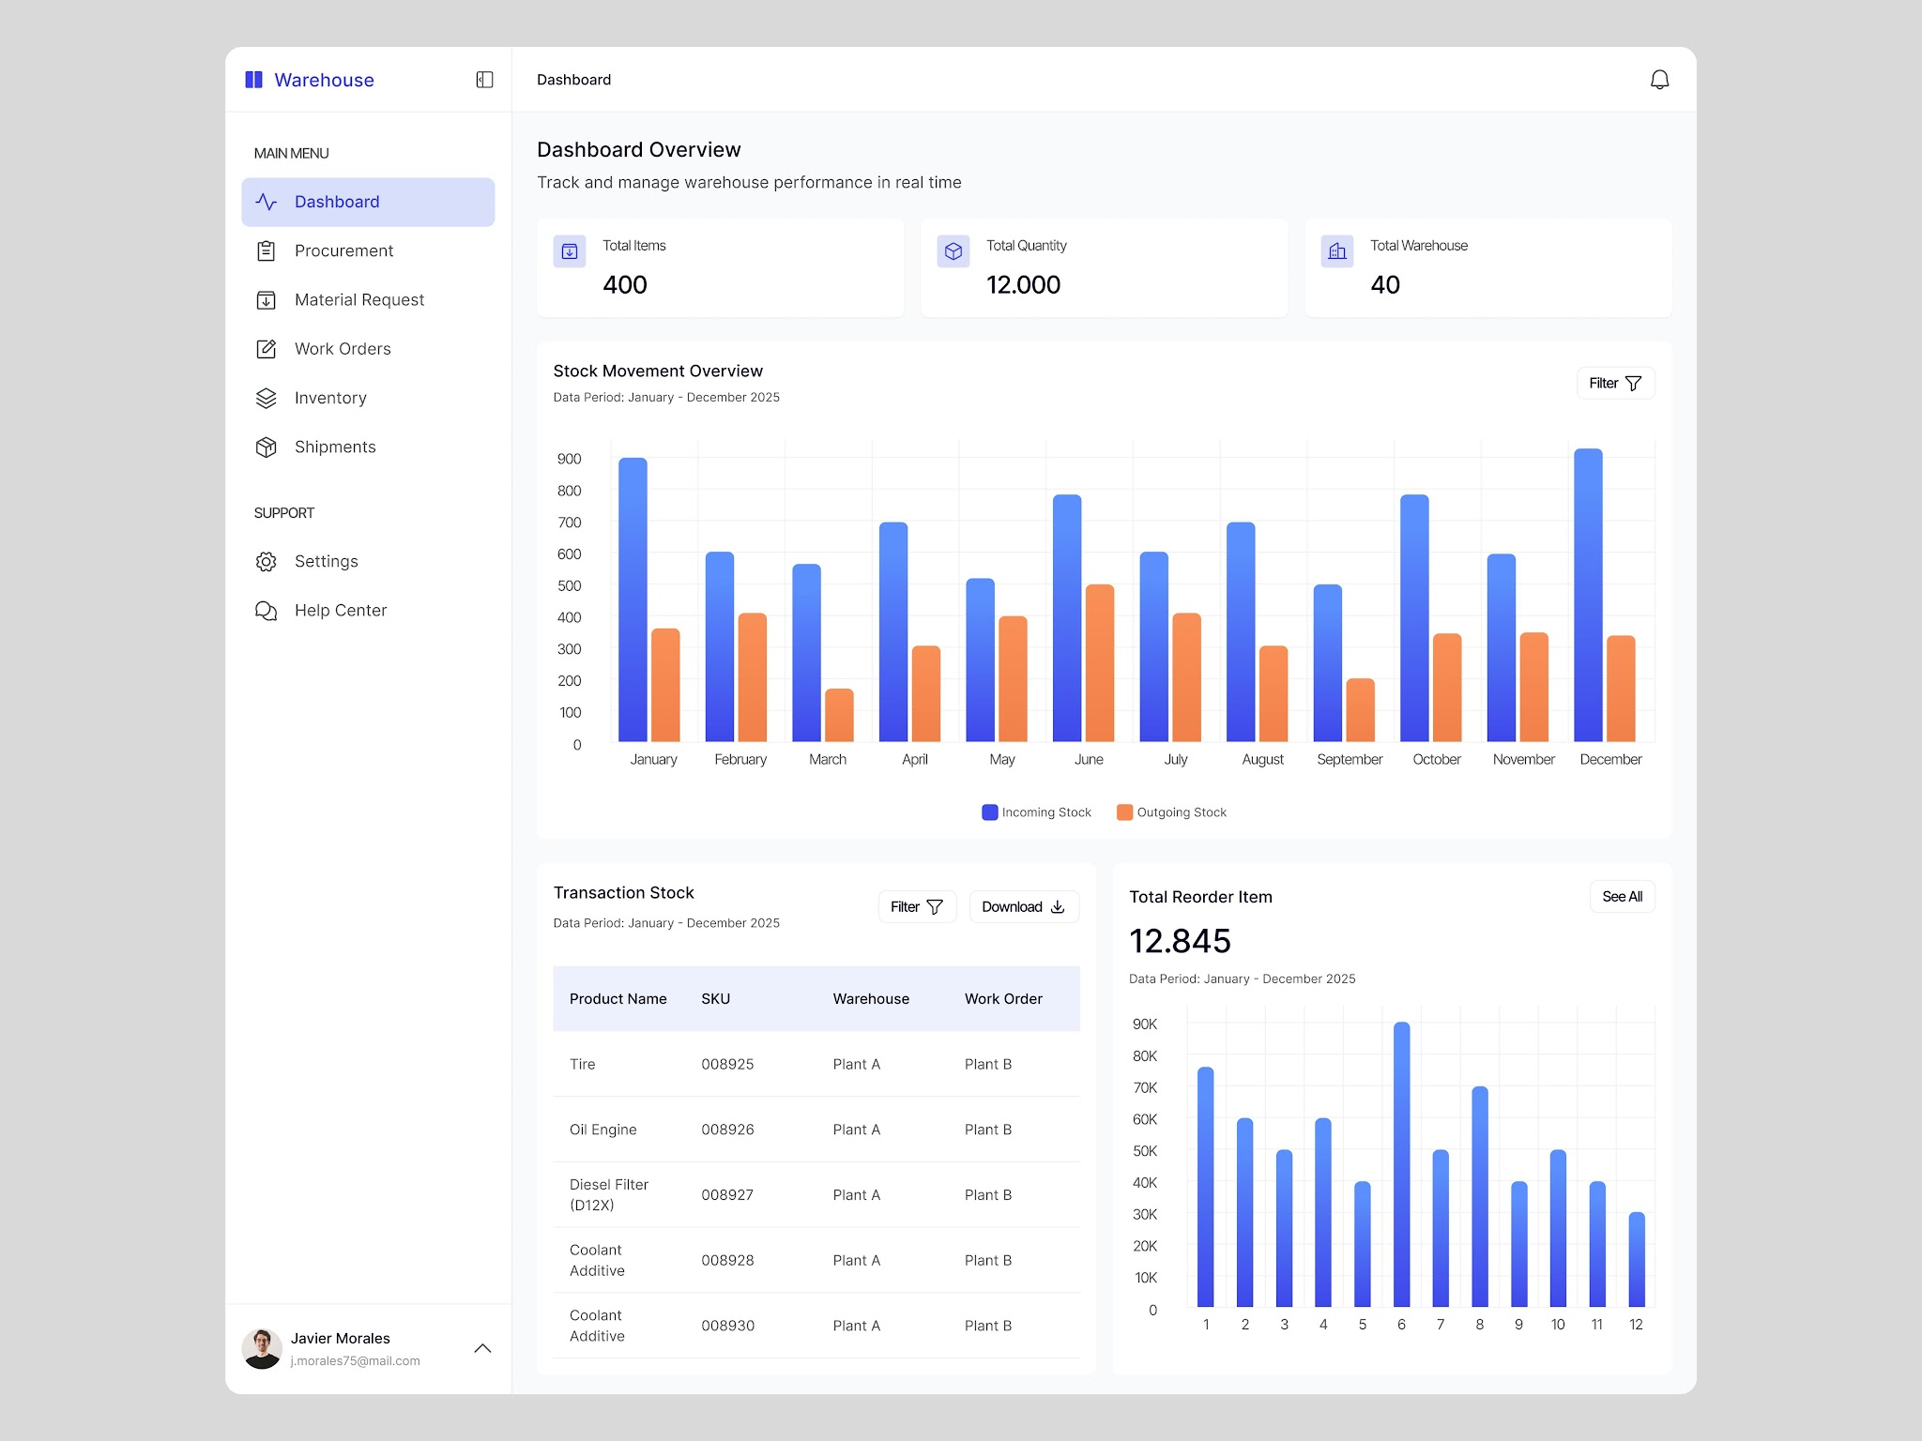
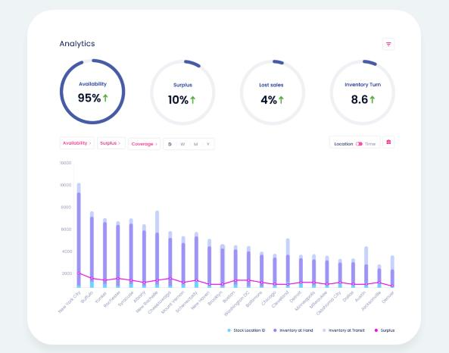
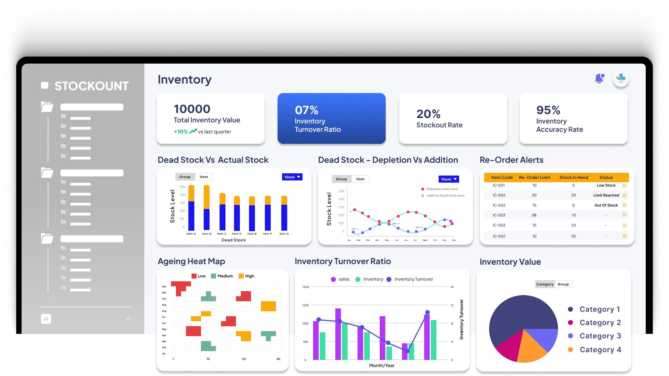
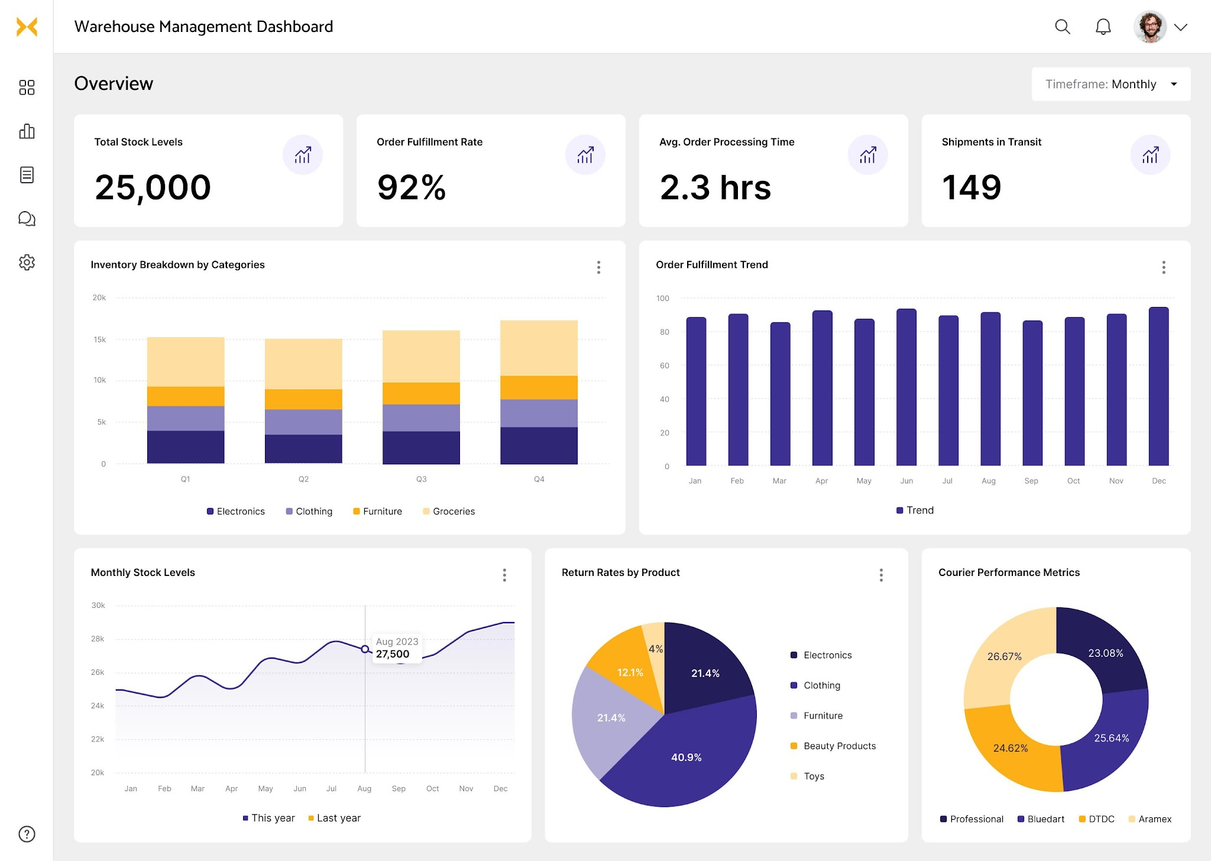
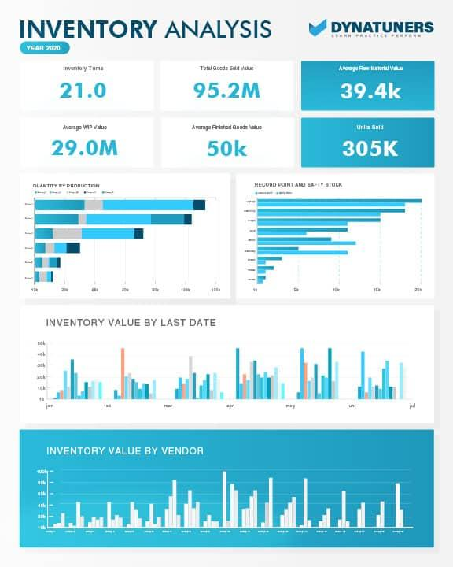
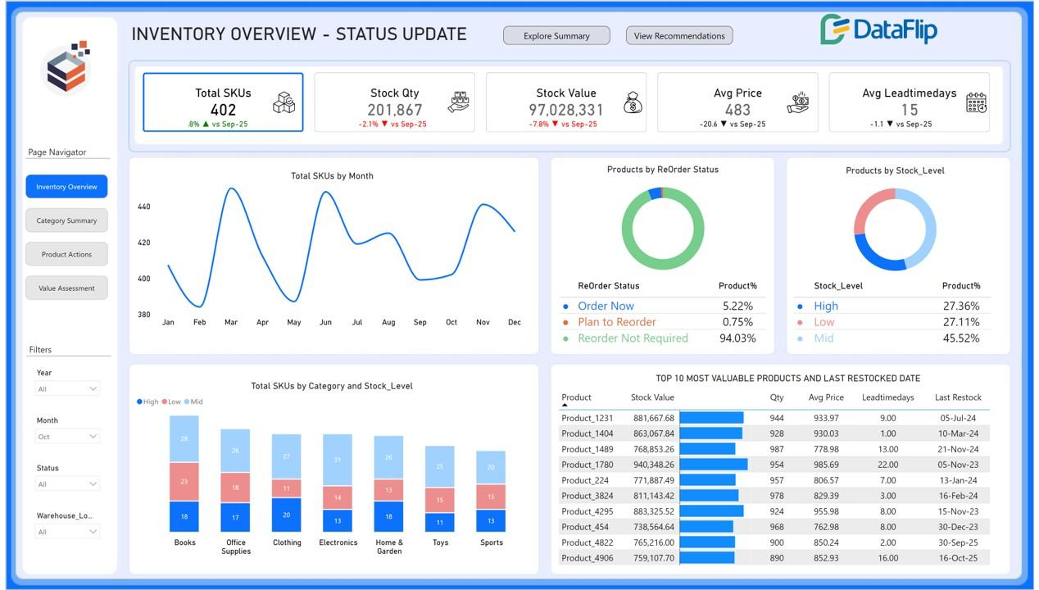

What is Inventory?
Inventory means available stock.
Example
Laptop
Current Stock

120

Sales Today
15

Remaining
105

Inventory Analytics tells
- Available Stock
- Out of Stock
- Low Stock
- Fast Moving Products
- Slow Moving Products

Example
Product

Laptop

Stock

120

Low Stock Alert

No

4. Inventory Forecasting
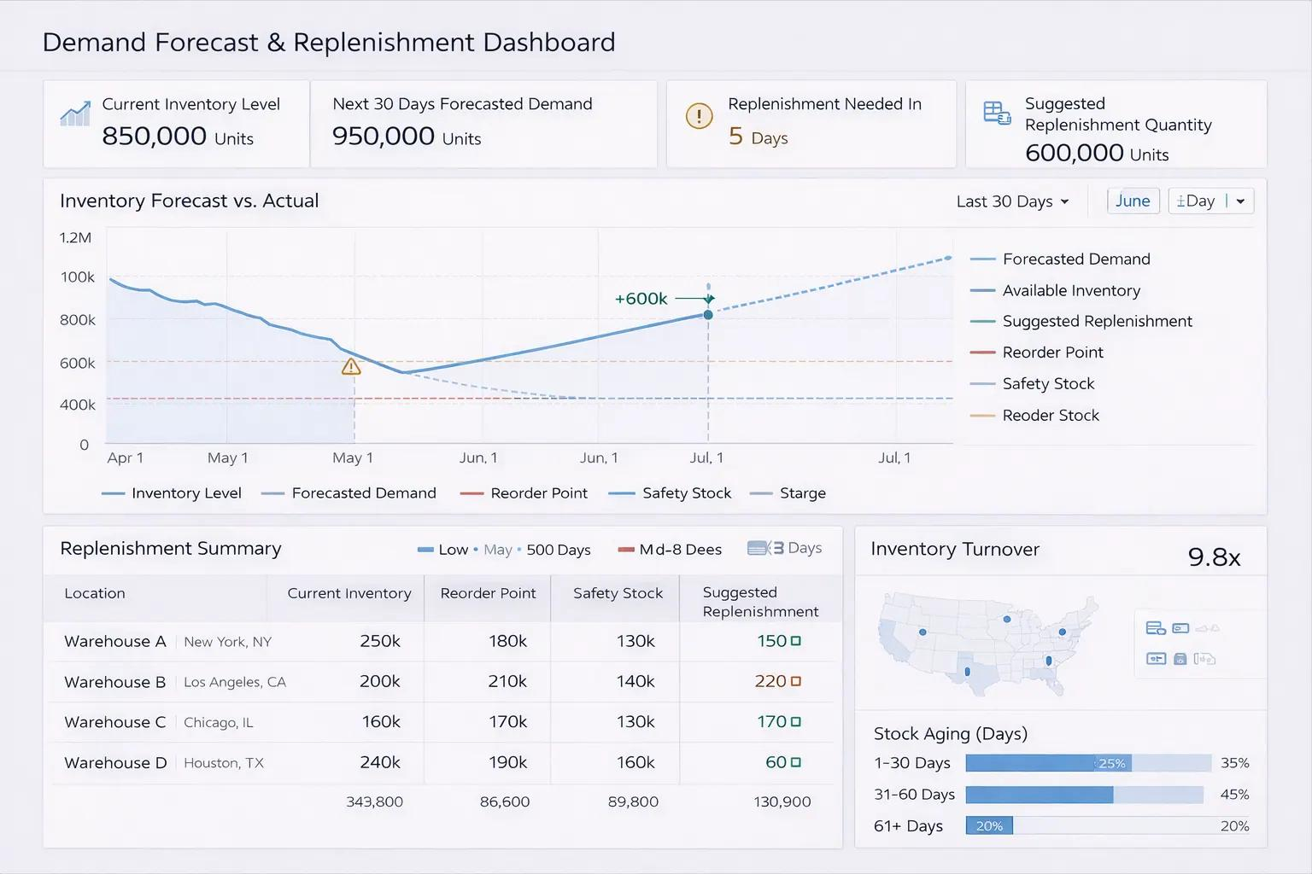
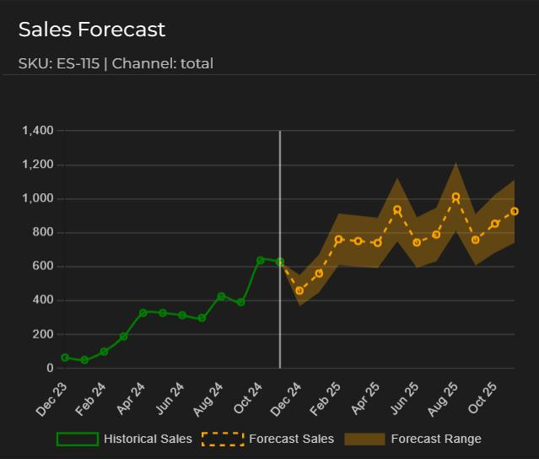
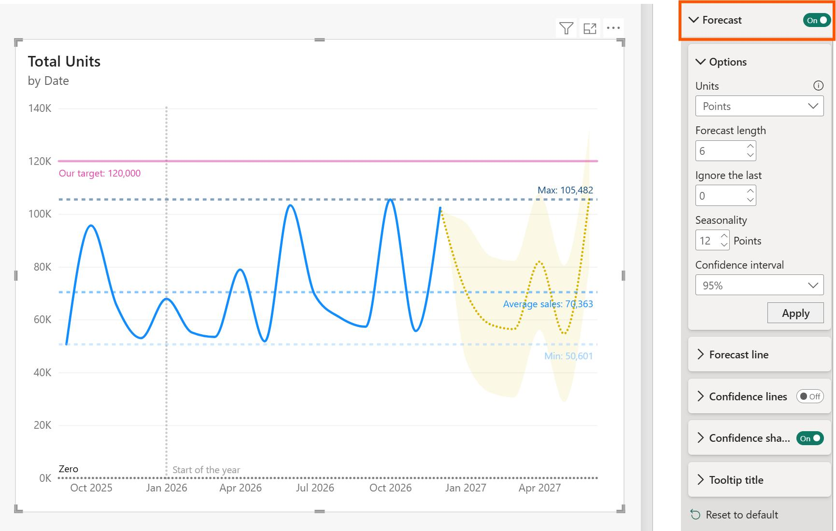
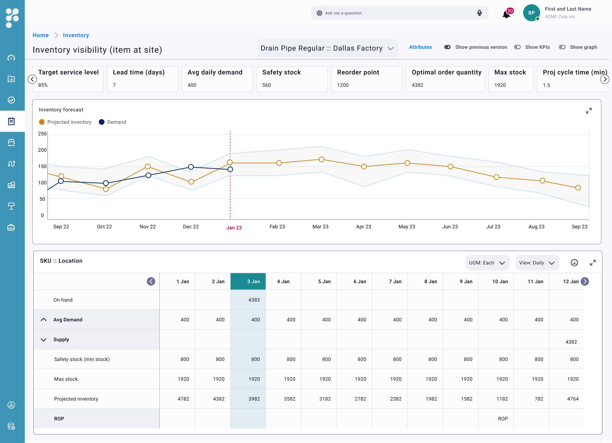
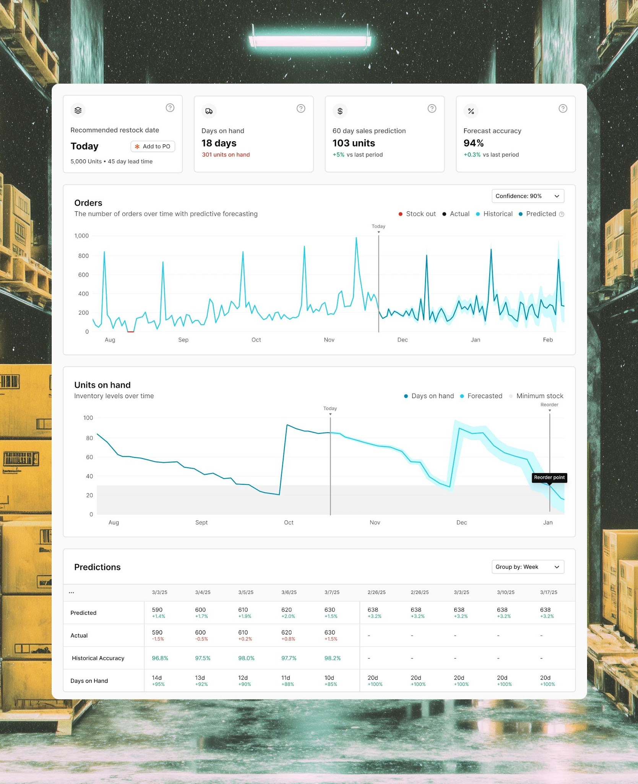
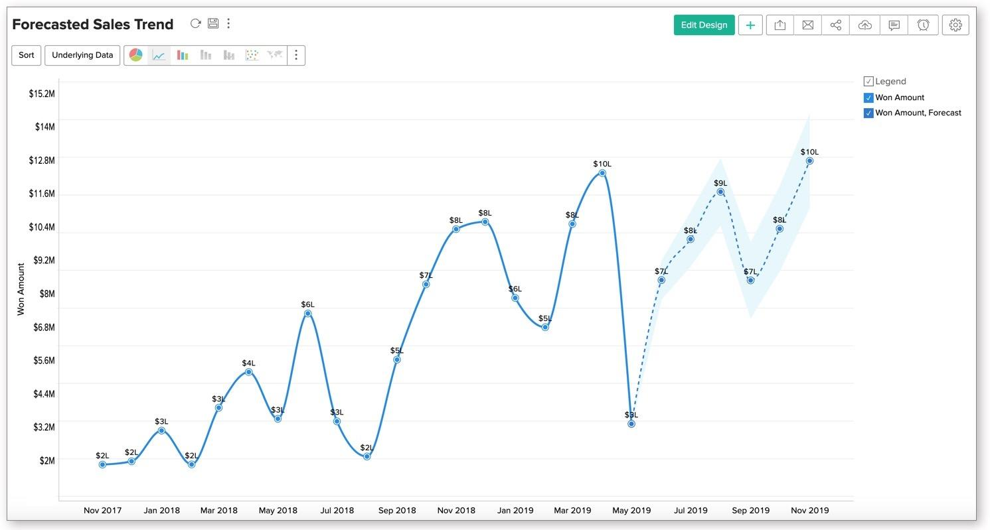

What is Forecasting?
Forecast means predicting the future.
Example
Last Month
100 laptops sold

Current Month
120 laptops sold

AI predicts
Next Month

145 laptops

Now company orders
150 laptops

before stock finishes.

Output
Current Stock

200

Expected Demand

260

Recommended Purchase

60

5. Revenue Intelligence
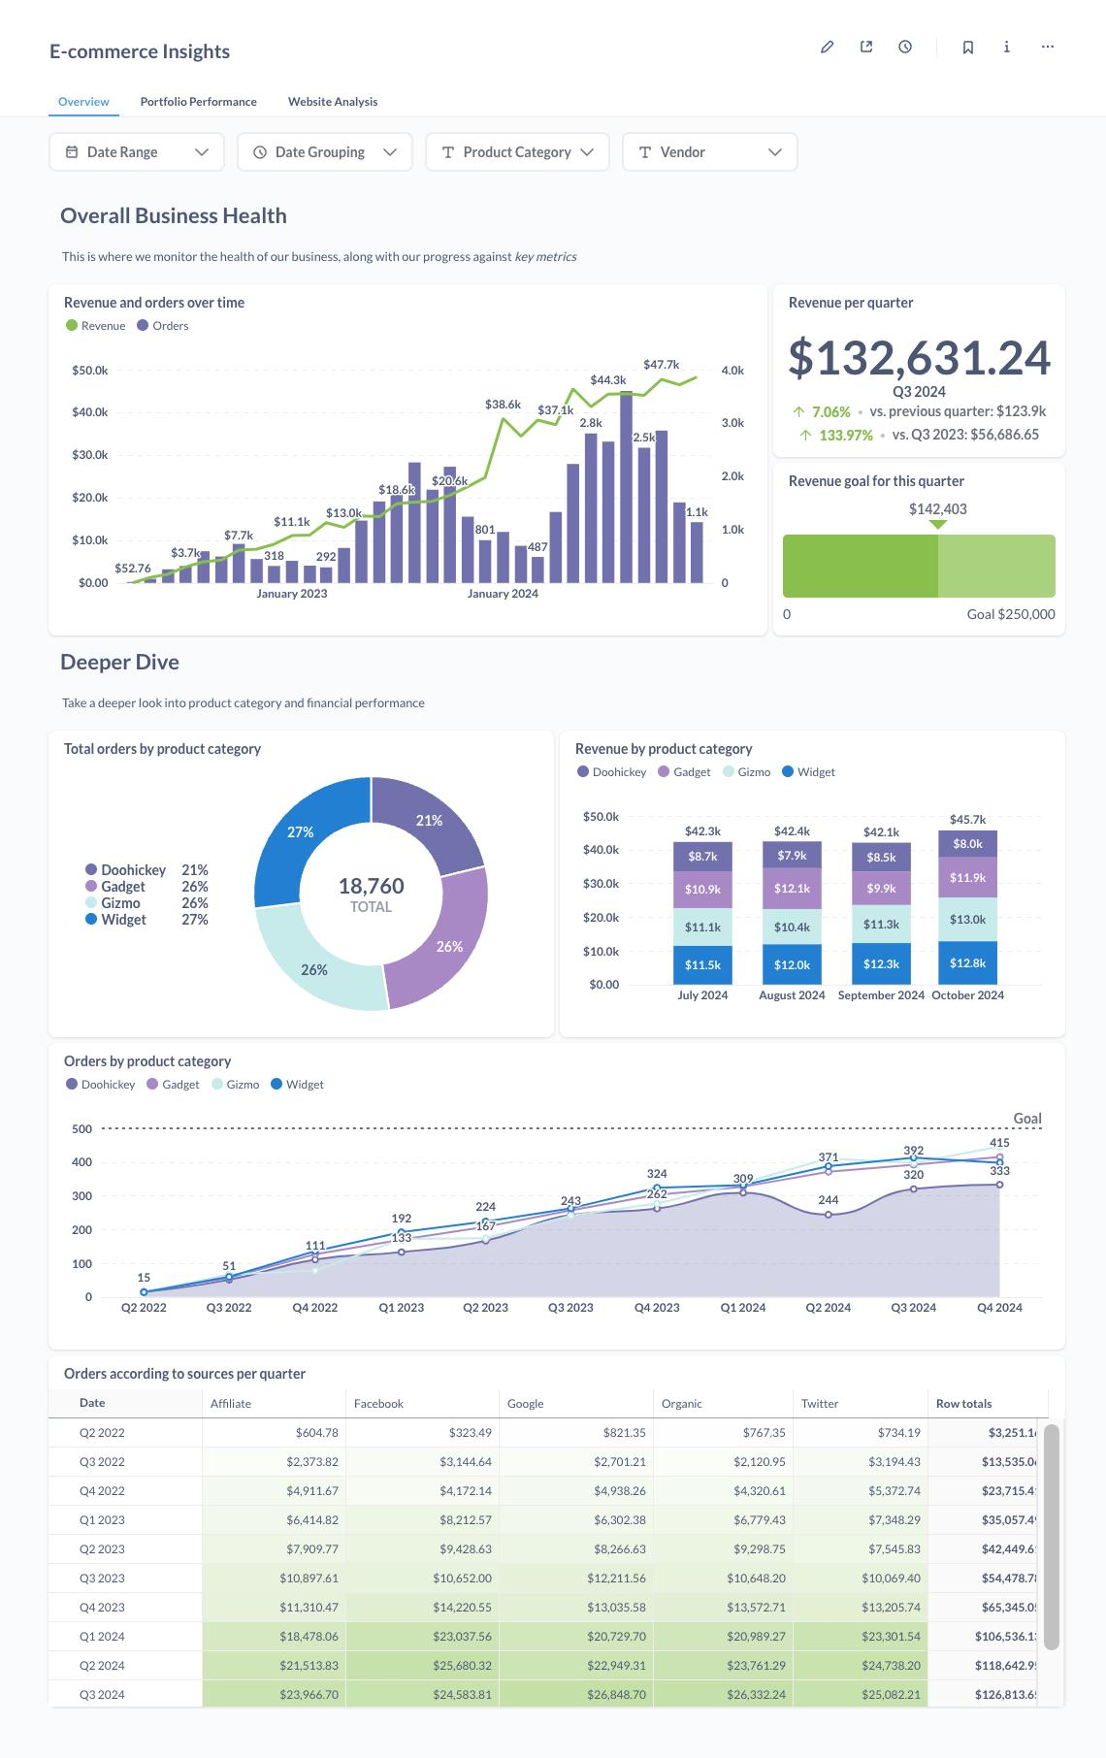
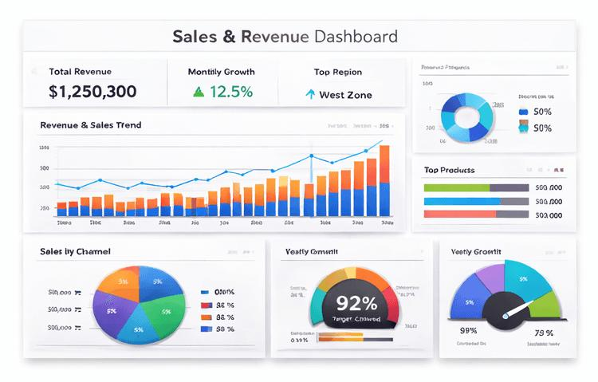
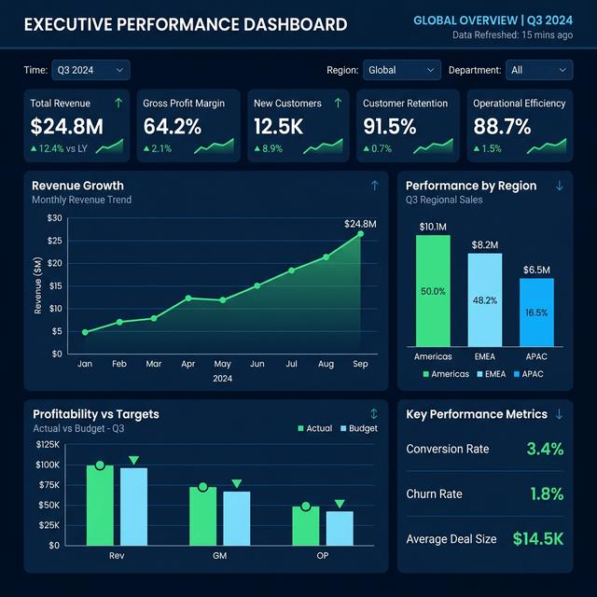
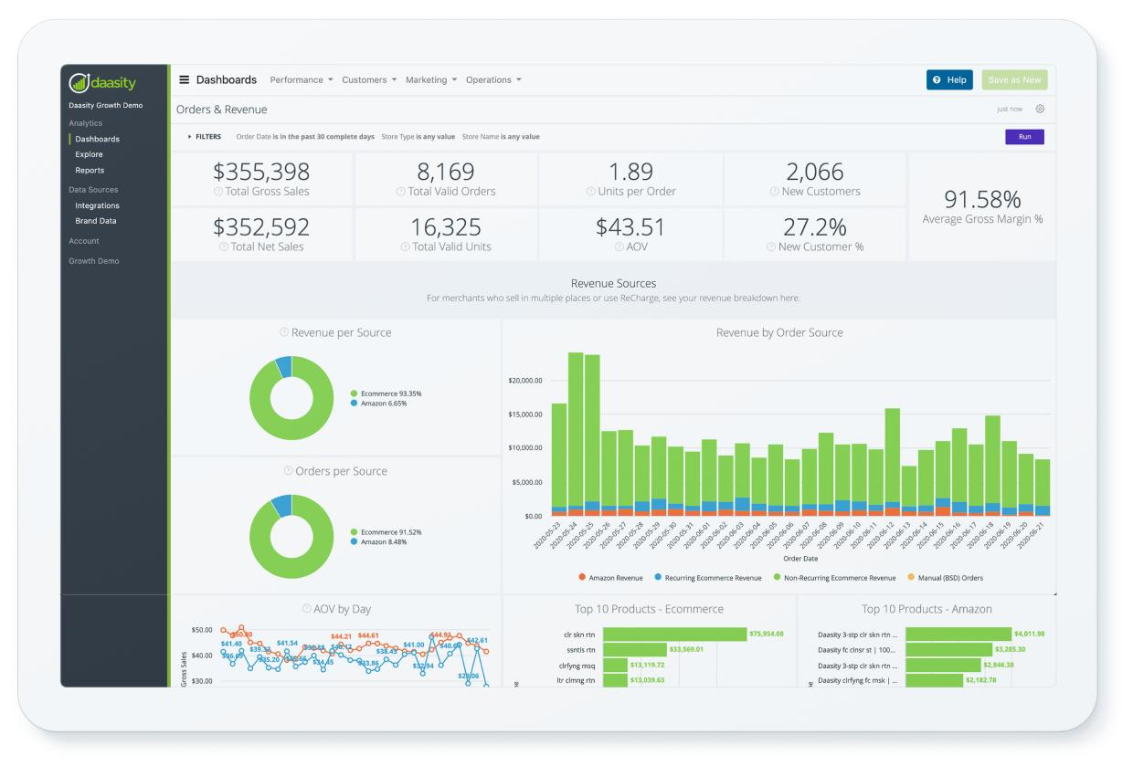
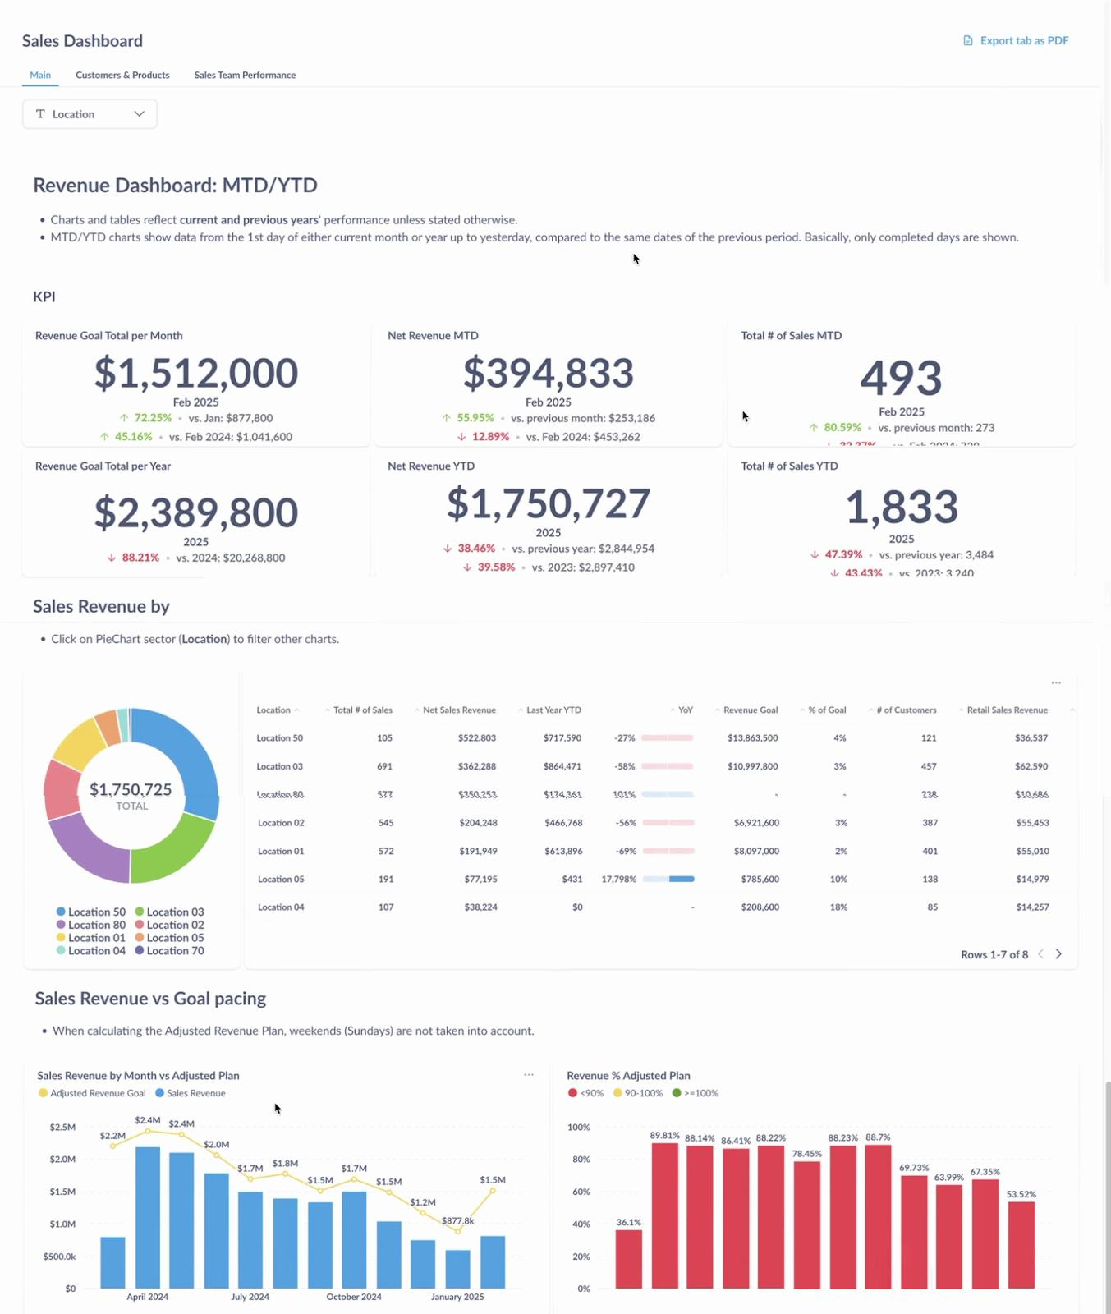
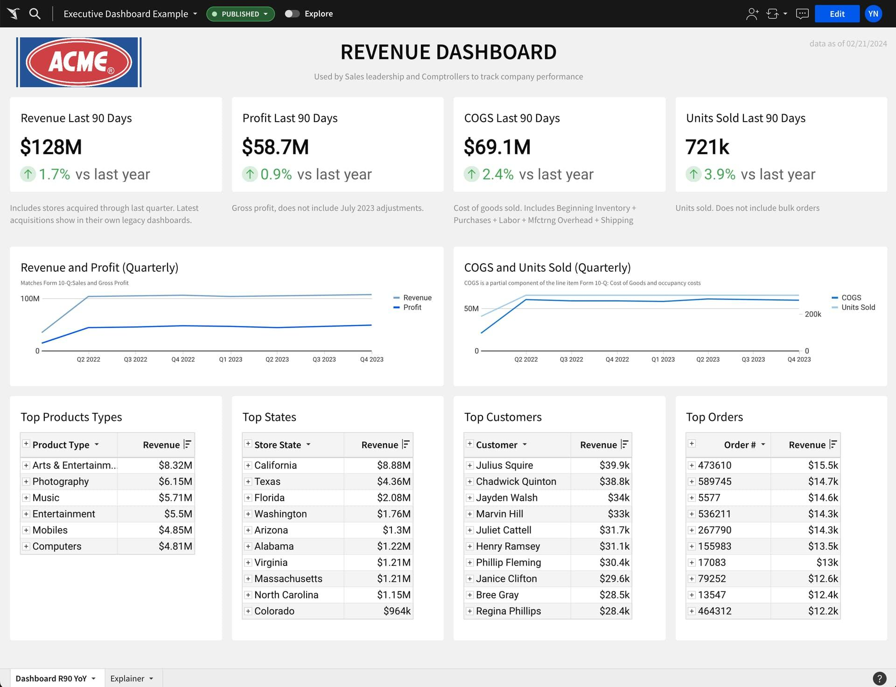
Revenue means money earned.
Revenue Intelligence tells
- Daily Revenue
- Monthly Revenue
- Profit
- Loss
- Average Order Value
- Growth
Example
January

$100,000

February

$135,000

Growth

35%

Useful charts
- Revenue Trend
- Profit Chart
- Monthly Sales

6. Vendor Ranking
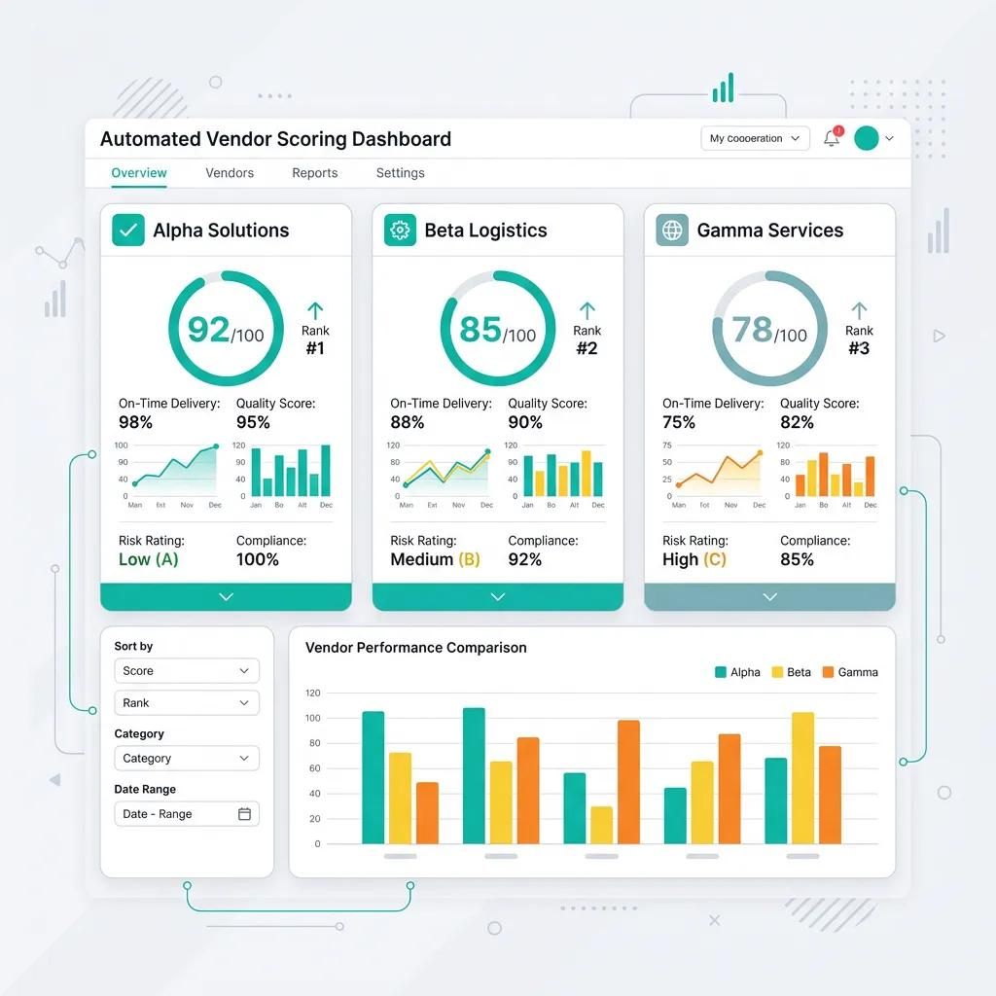
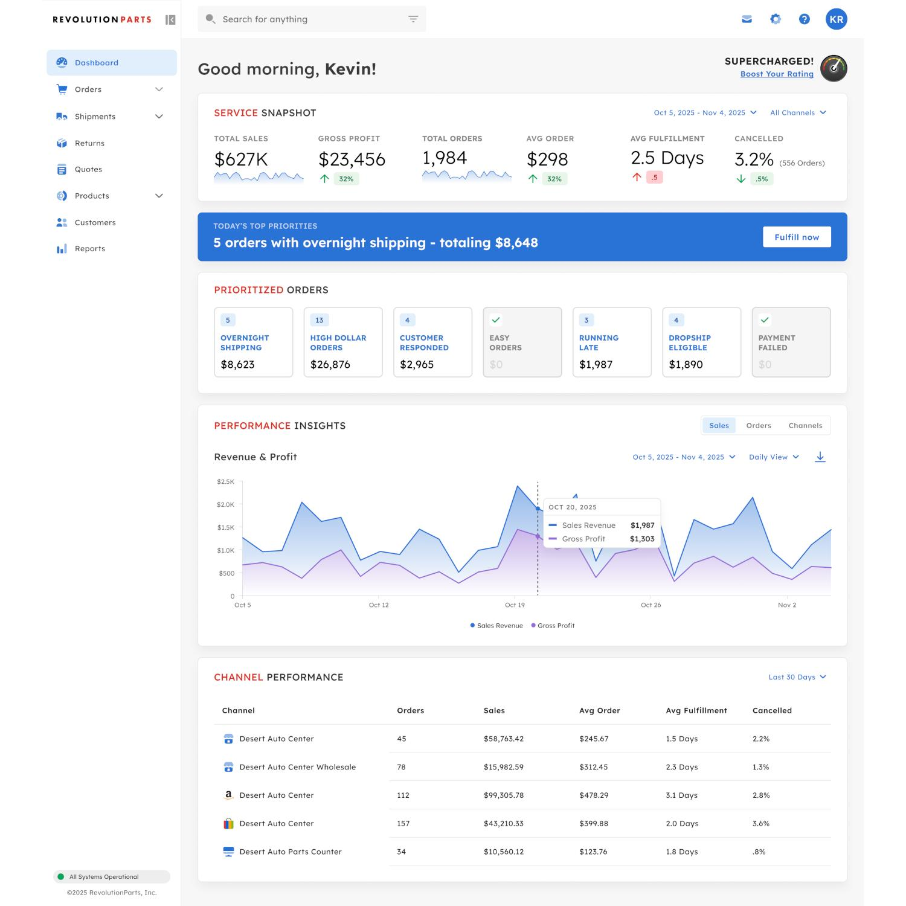
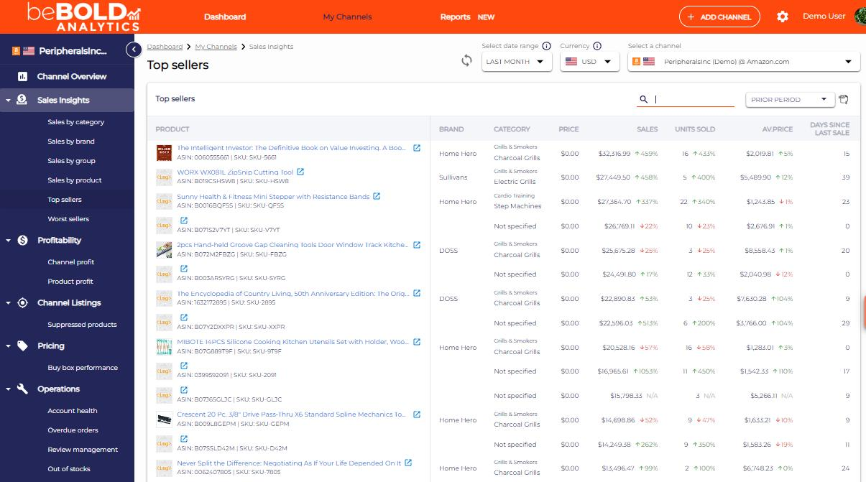
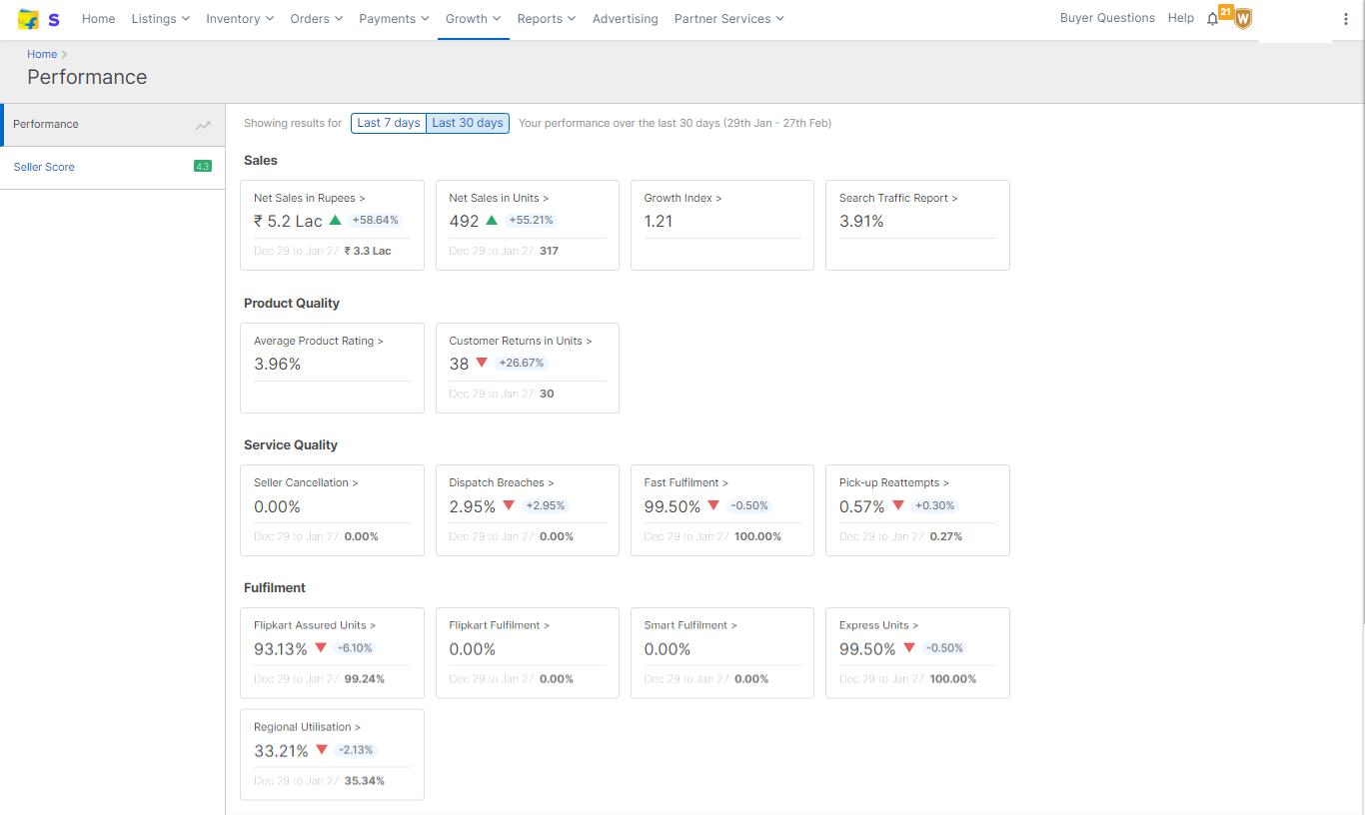
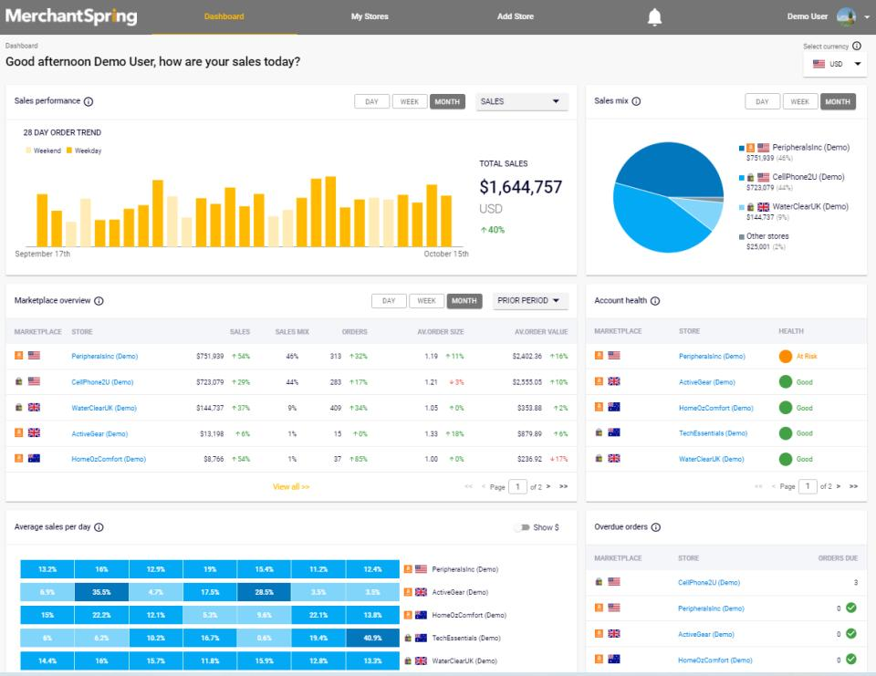
Every vendor is ranked.
Ranking is based on
- Revenue
- Customer Rating
- Delivery Speed
- Order Completion
- Returns
Example
Rank | Vendor | Revenue
1 | ABC Electronics | $500K
2 | XYZ Mobiles | $420K
3 | Smart Gadgets | $390K
Best vendor gets Rank 1.

7. FastAPI
No image needed.
FastAPI is used to build APIs.
API means communication between applications.
Example
Student opens app
↓
Dashboard requests
GET /vendors

Server returns
[
{
"id":1,
"name":"ABC Electronics"
}
]

Advantages
- Very Fast
- Easy
- Automatic Documentation
- JSON Response

8. PostgreSQL + SQLAlchemy
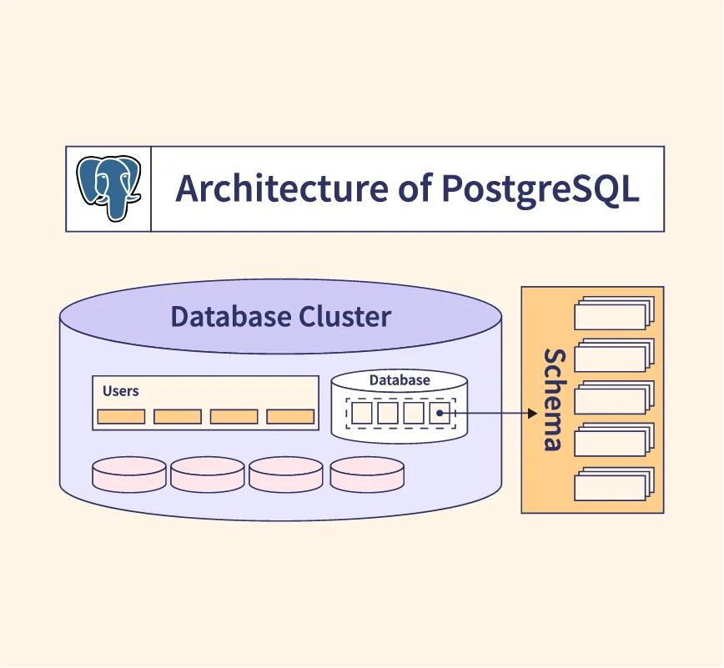
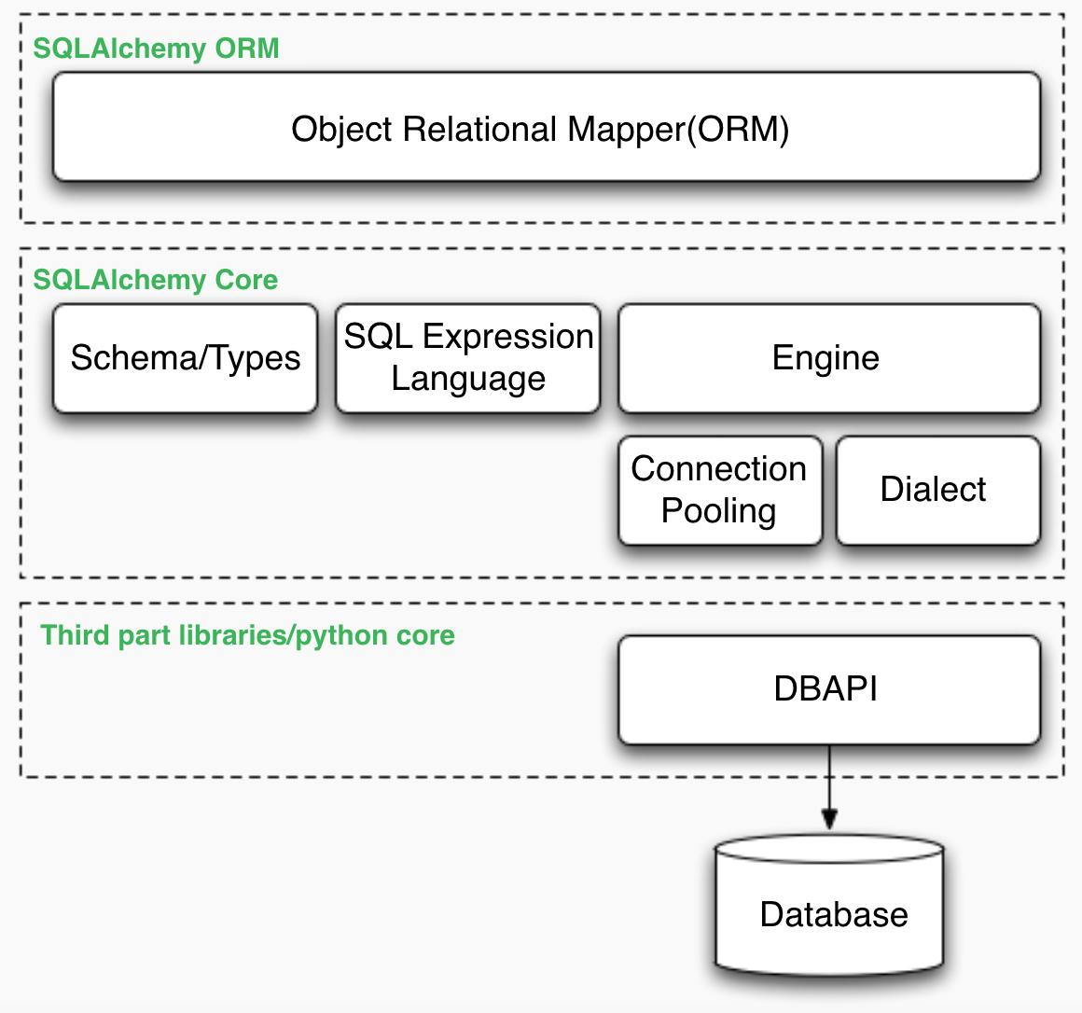
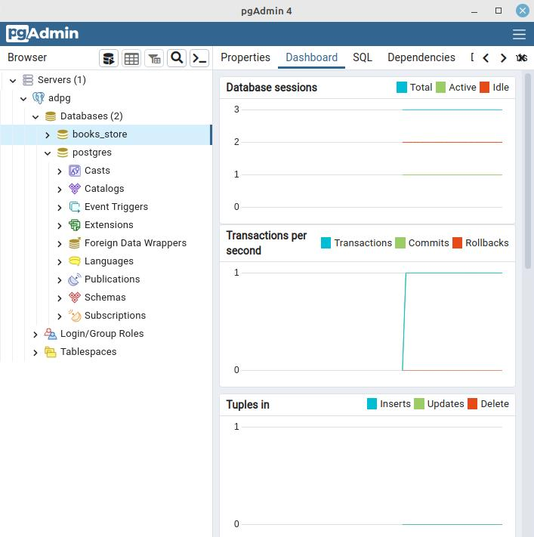

PostgreSQL
Database
Stores
- Vendors
- Products
- Customers
- Orders
Example
Vendor Table
ID | Vendor
1 | ABC
2 | XYZ

SQLAlchemy
Python cannot directly understand SQL.
SQLAlchemy converts Python into SQL.
Example
Python
Vendor.query.all()

SQLAlchemy converts into
SELECT * FROM vendors;

9. MLflow
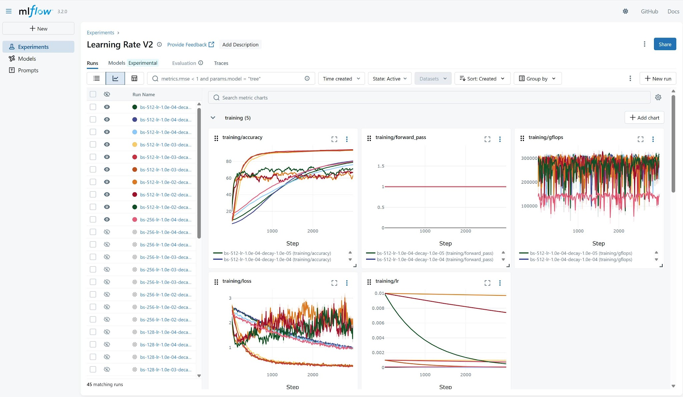
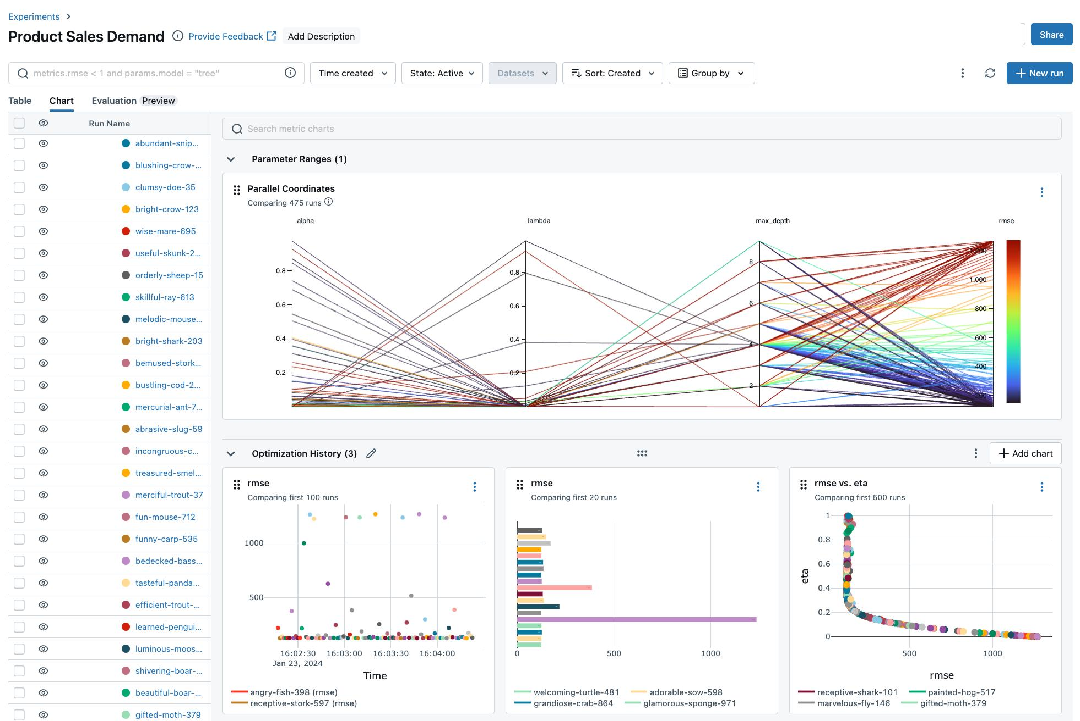
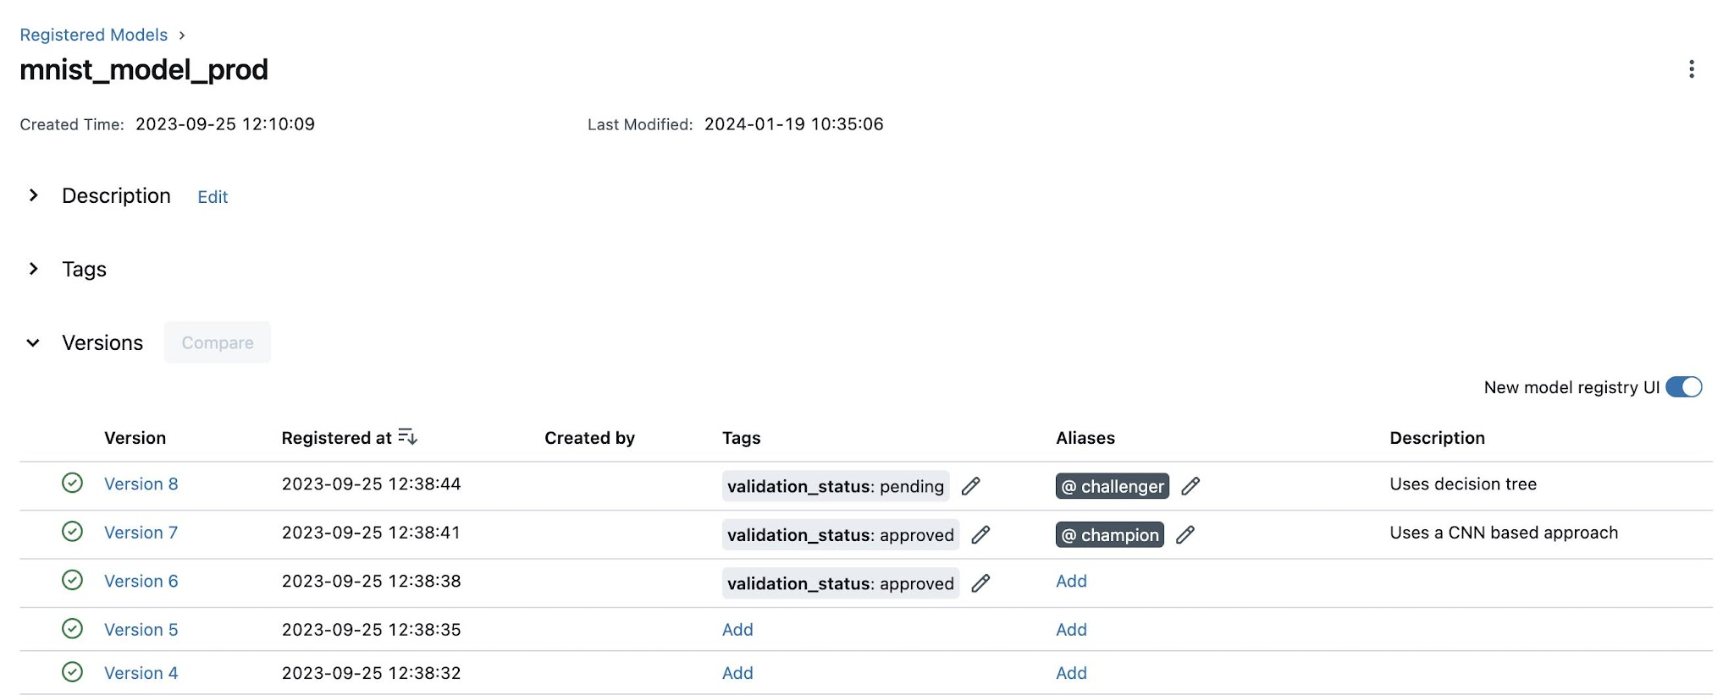
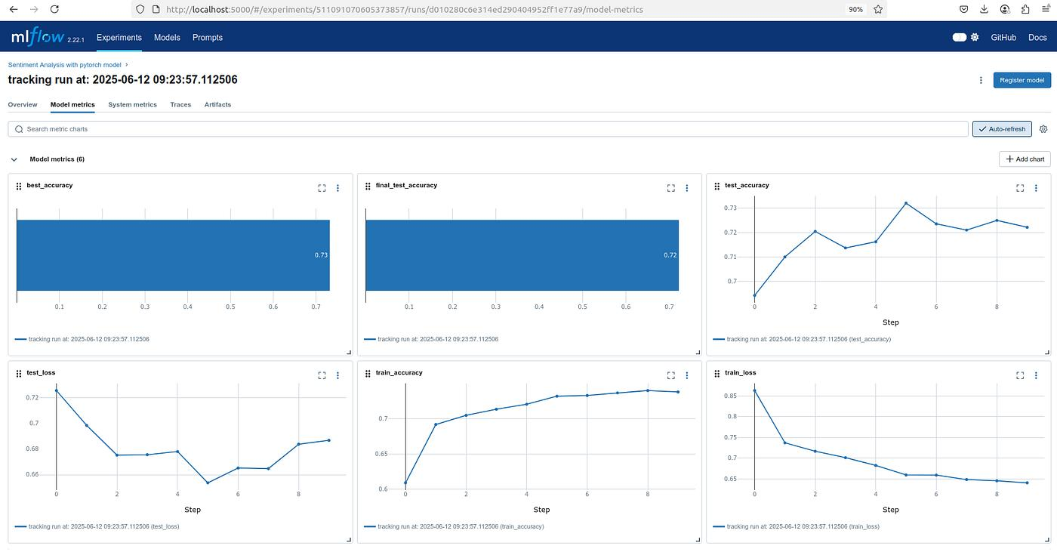
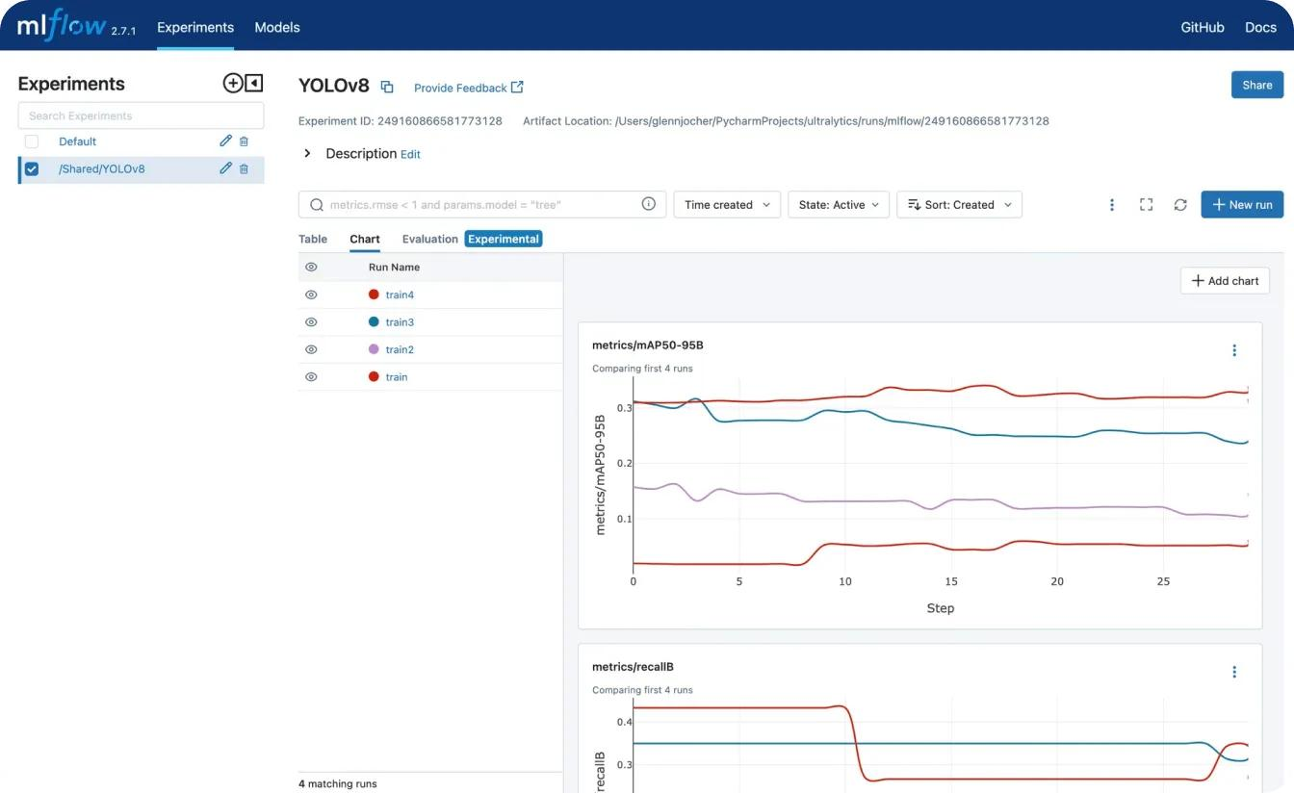
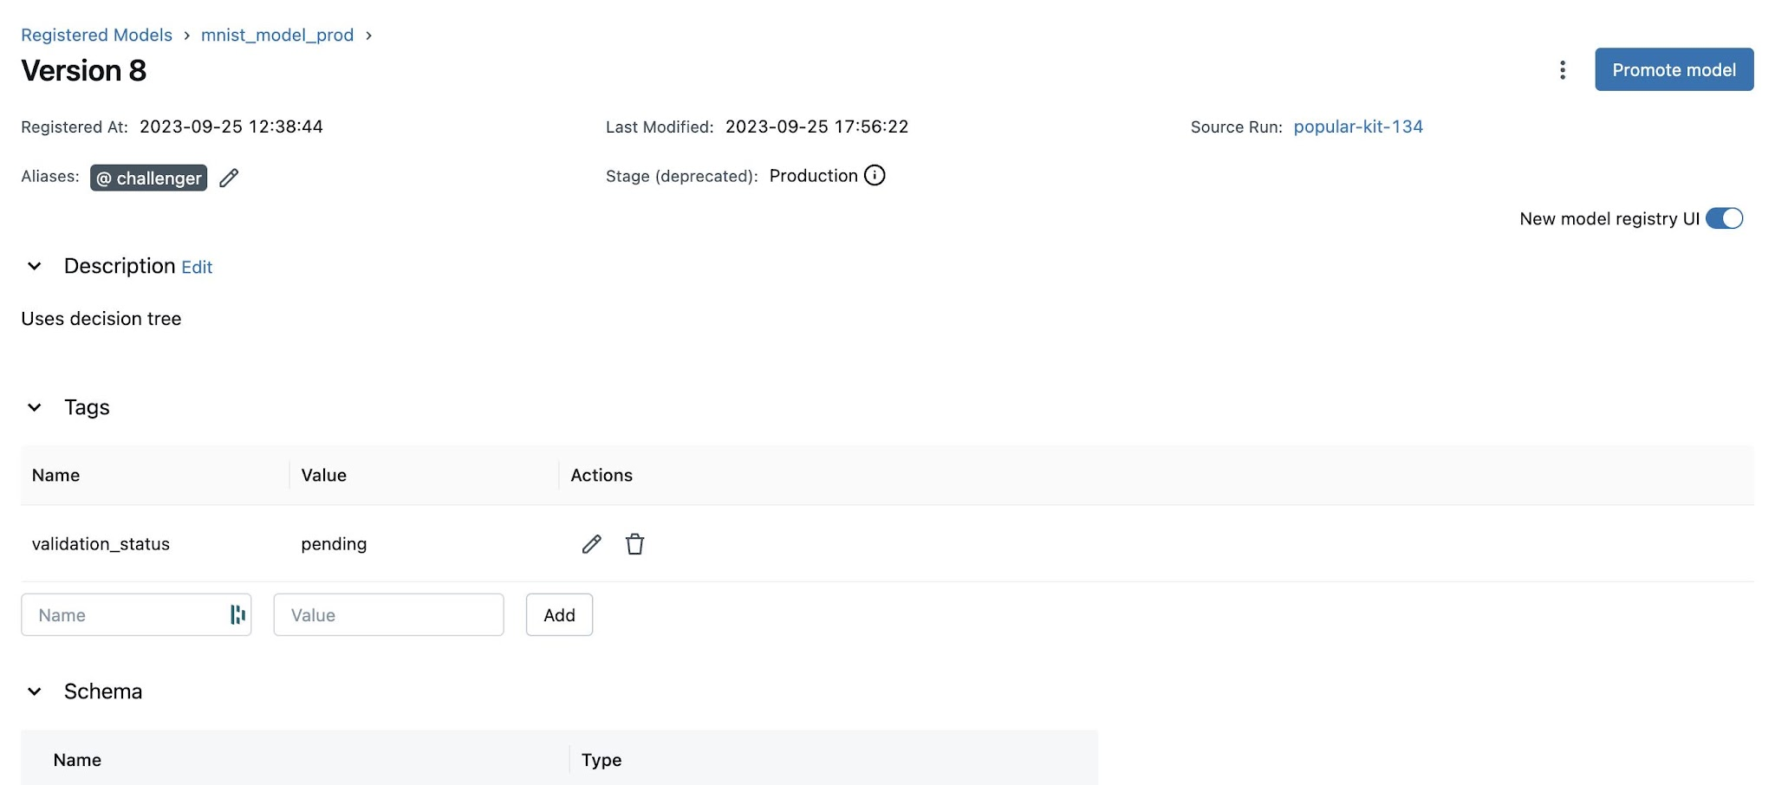
MLflow manages Machine Learning models.
It stores
- Accuracy
- Parameters
- Version
- Models
Example
Model V1

Accuracy

88%

Model V2
Accuracy

91%

Choose Model V2.

10. ETL Pipeline
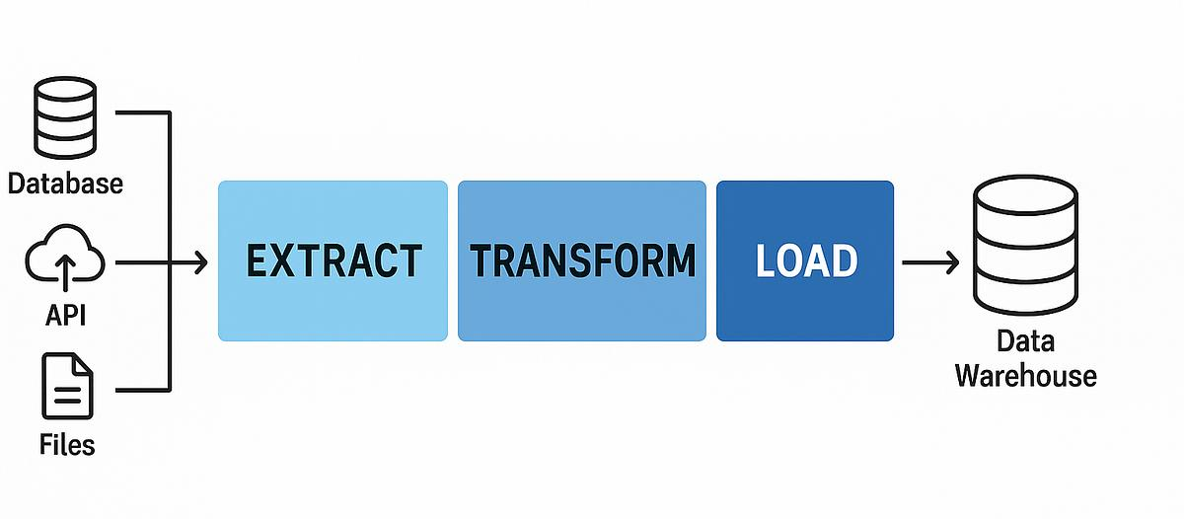
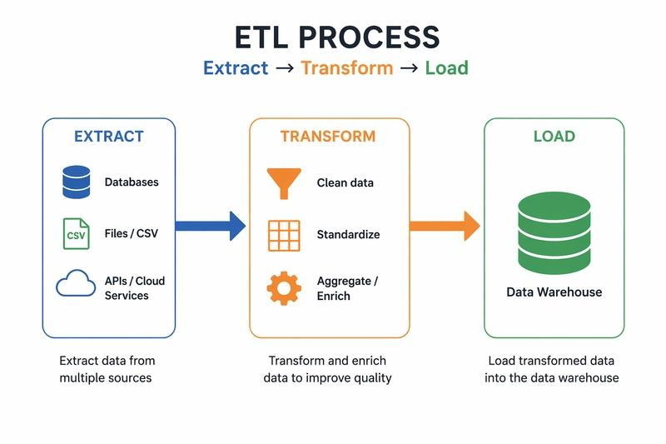
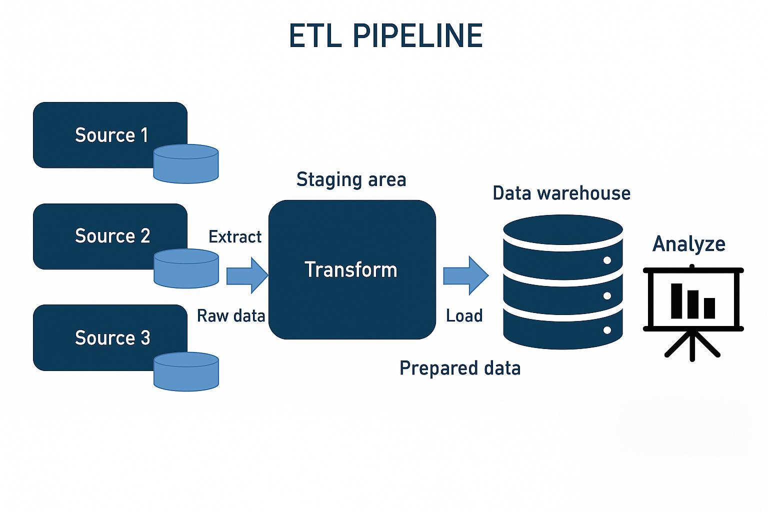
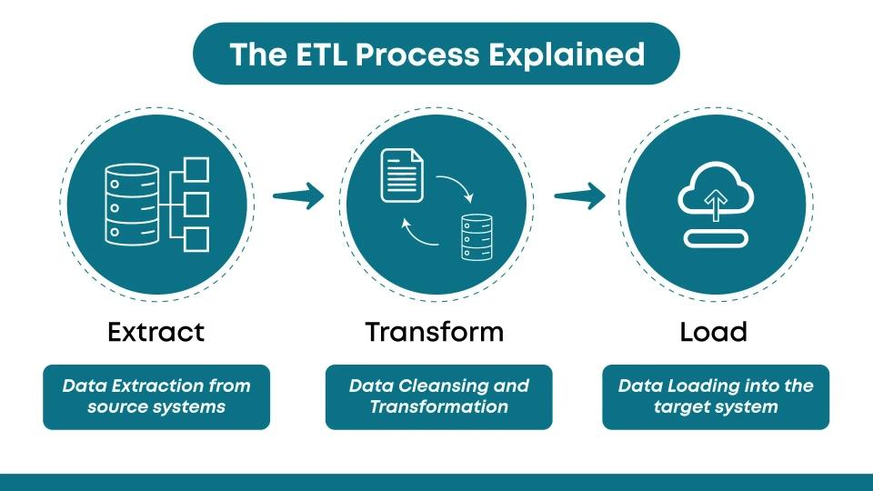
ETL
Means
Extract
↓
Transform
↓
Load
Example
Extract
Orders.csv

Transform
Remove duplicates

Fill missing values

Convert dates

Load
PostgreSQL Database

11. Docker
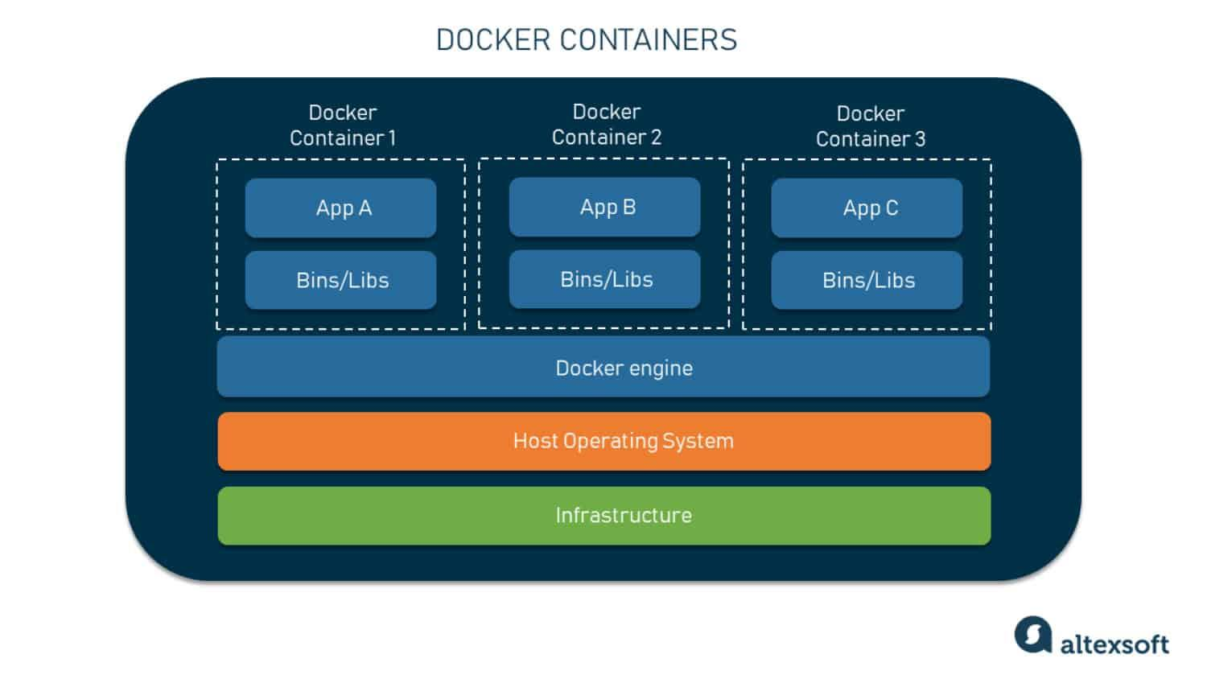
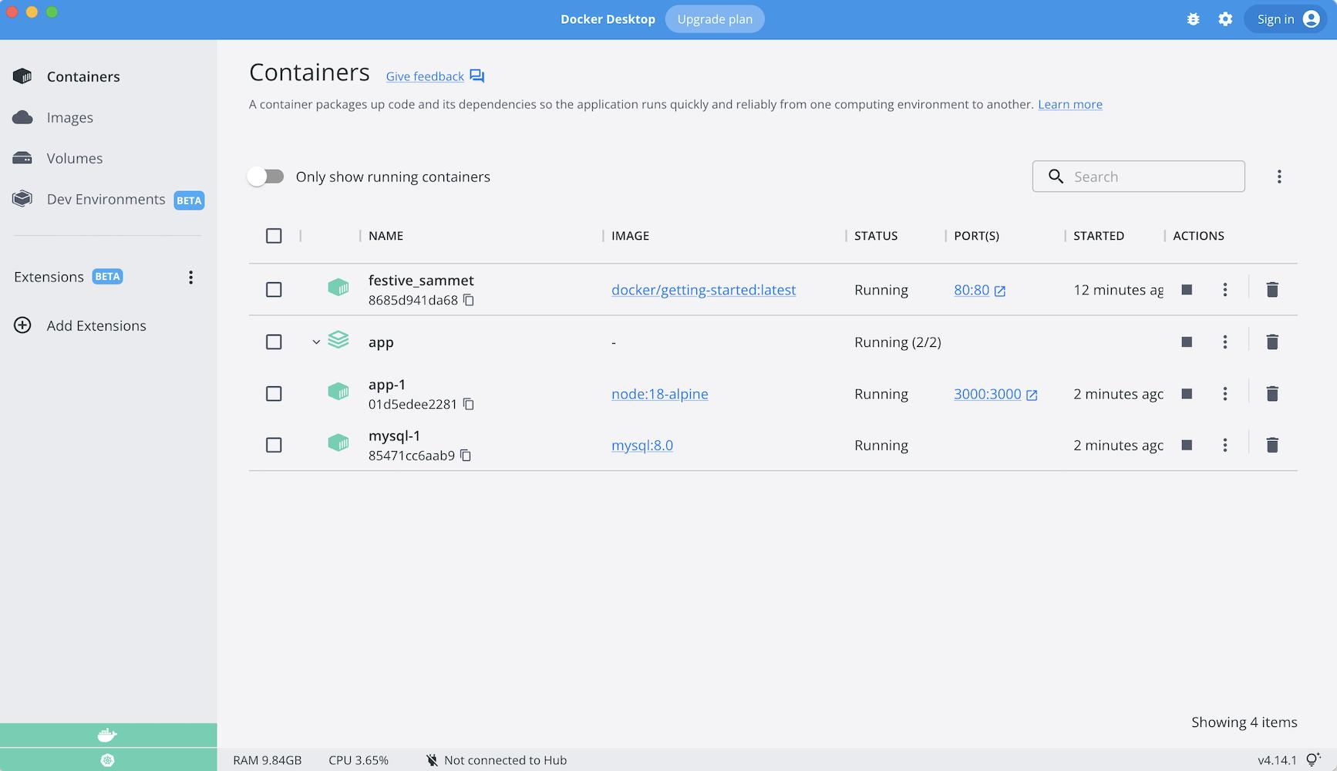
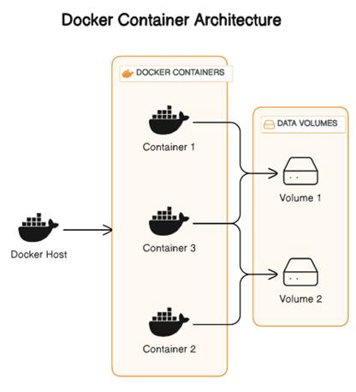
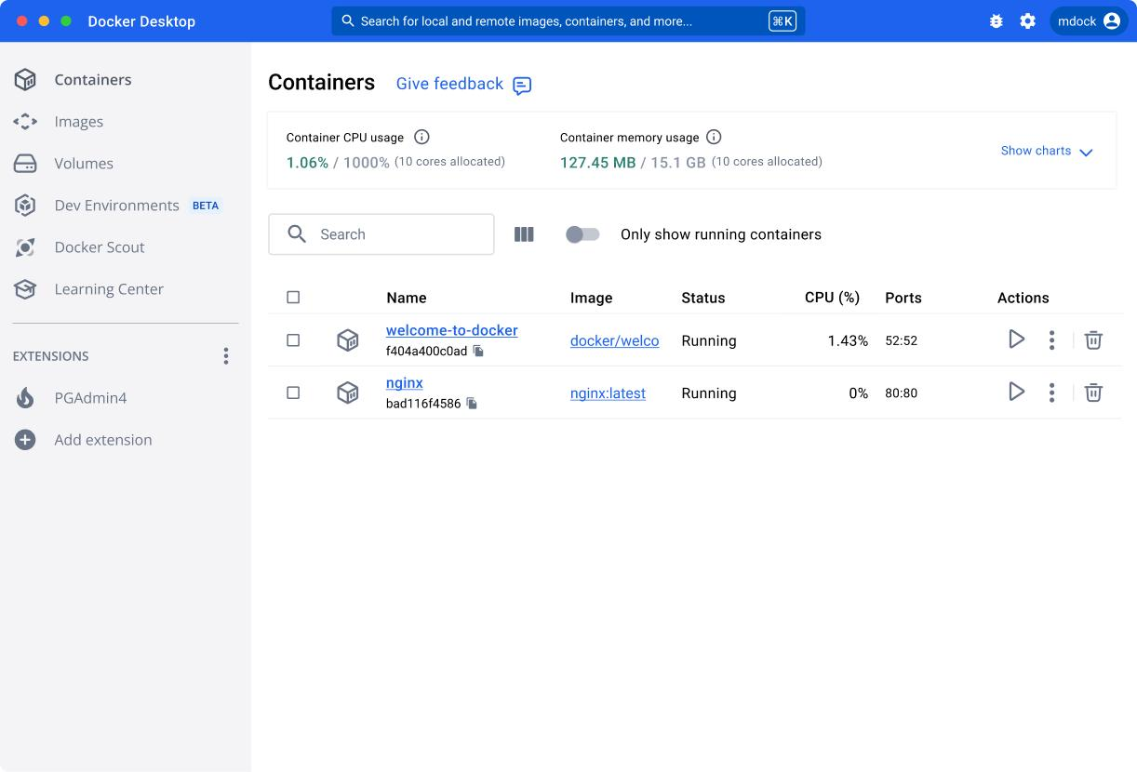
Docker packages the complete project into one container.
Without Docker
Python

Libraries

Database

Models

Need manual installation

With Docker
One command

docker run shopsense

Everything runs.

12. GitHub Actions
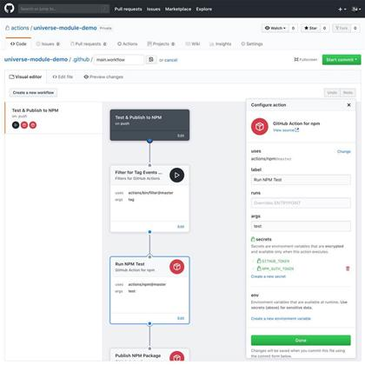
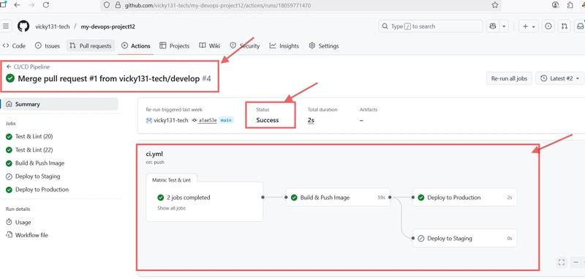
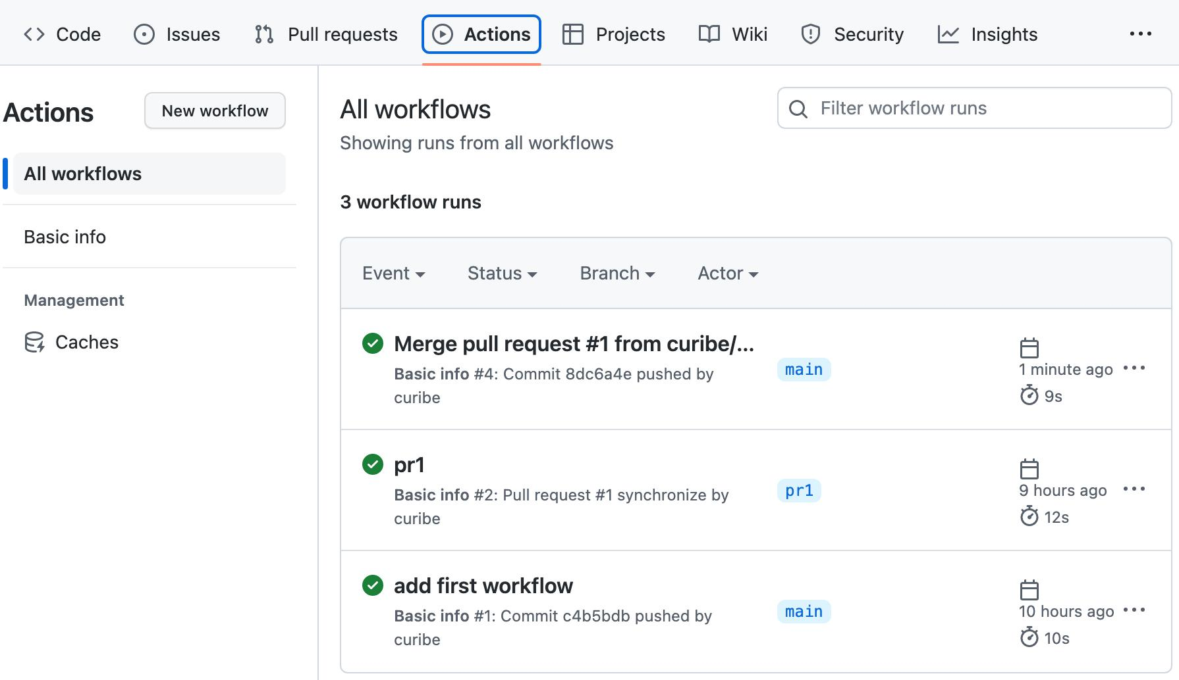
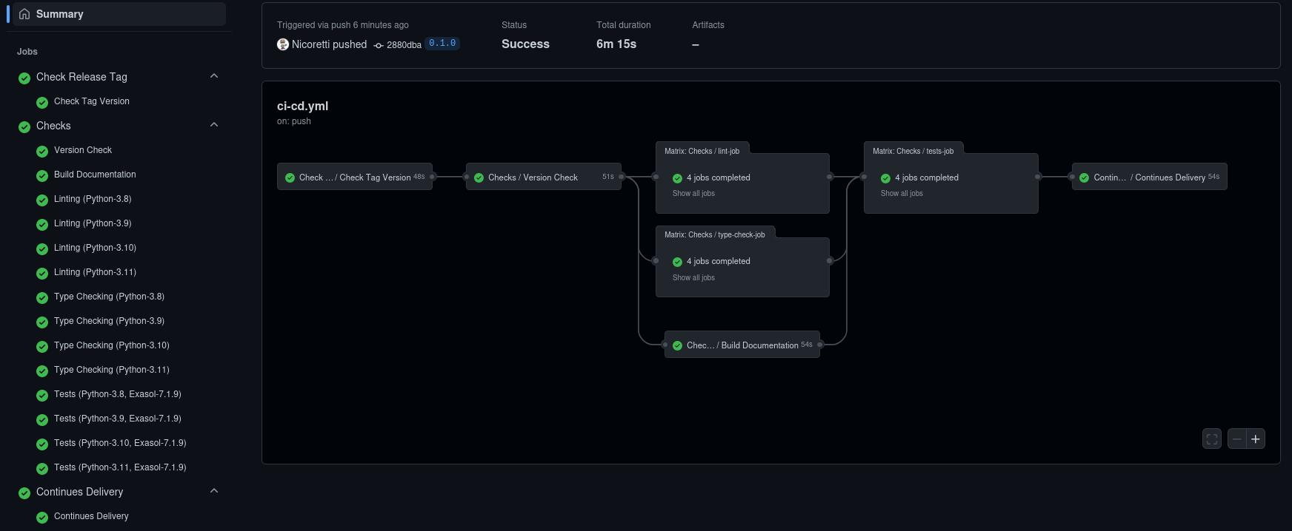
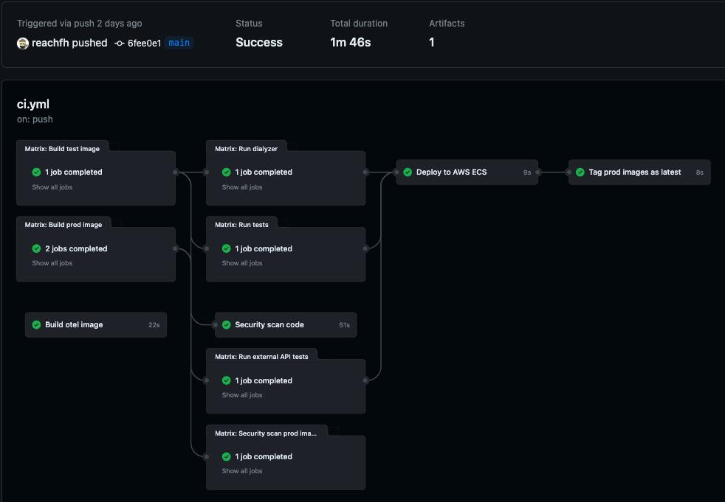
GitHub Actions automates project testing and deployment.
Developer
↓
Push Code
↓
GitHub Actions automatically
- Install packages
- Run tests
- Build Docker image
- Deploy
Example
Push Code

↓

Testing

↓

Build

↓

Deploy

↓

Completed

13. BI (Business Intelligence) Dashboard
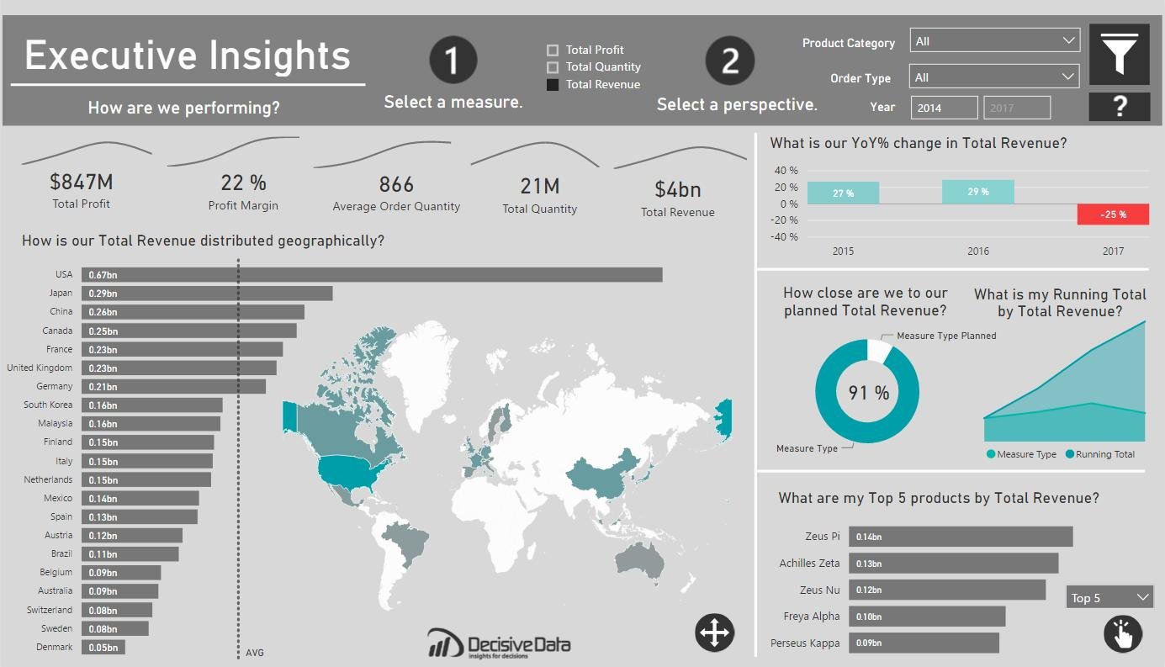
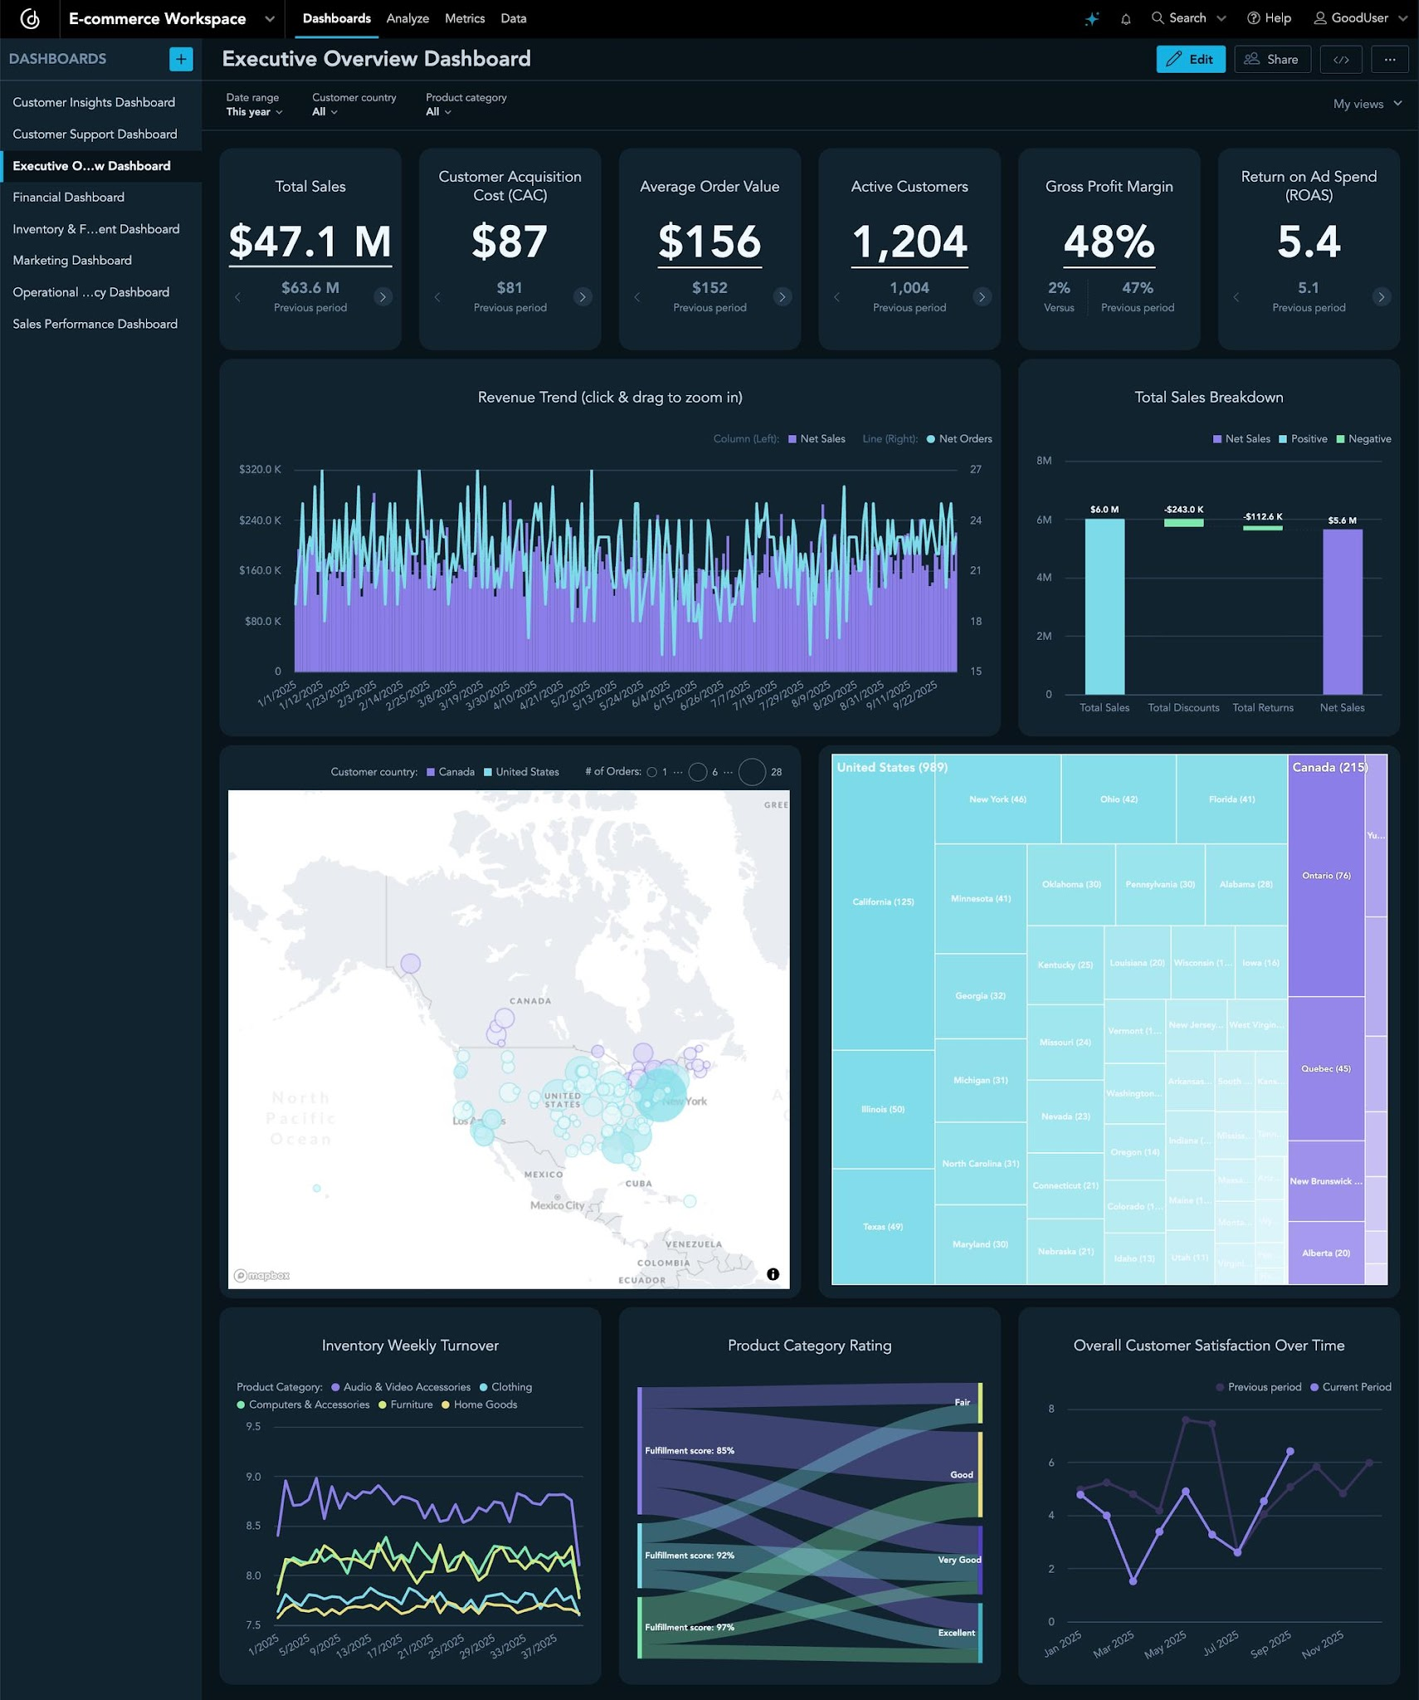
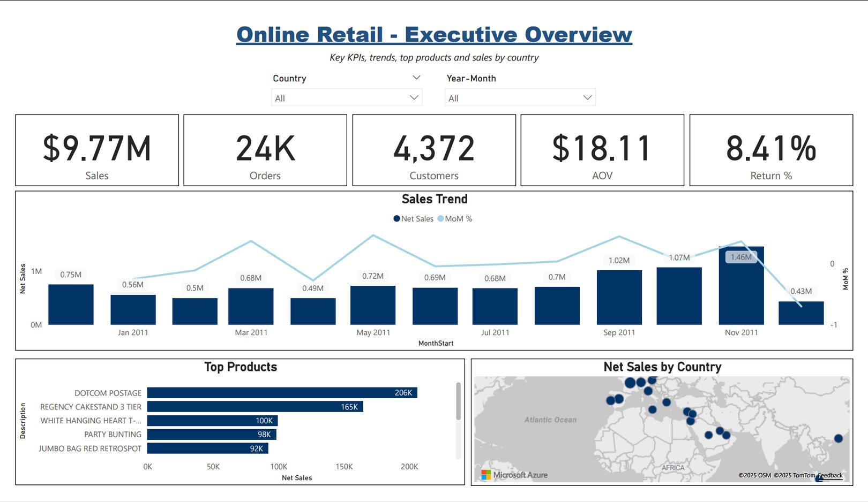
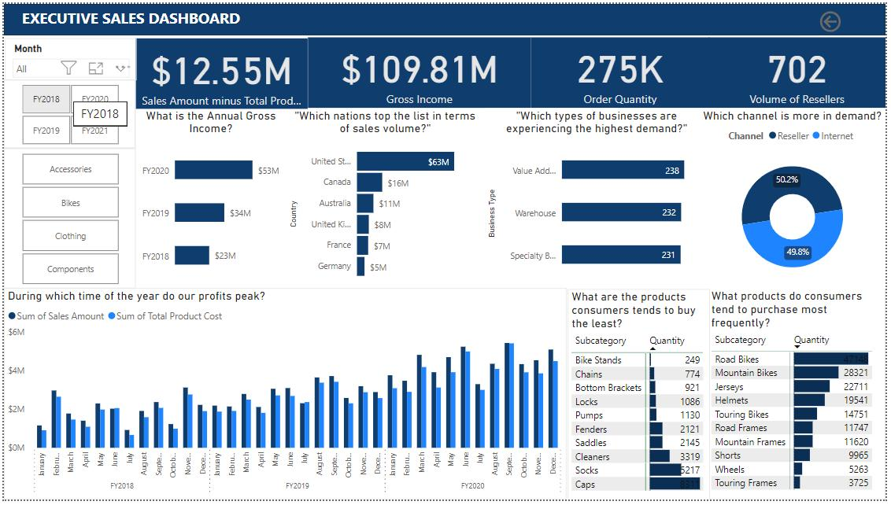
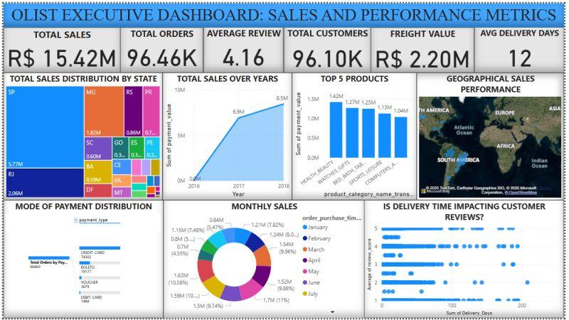
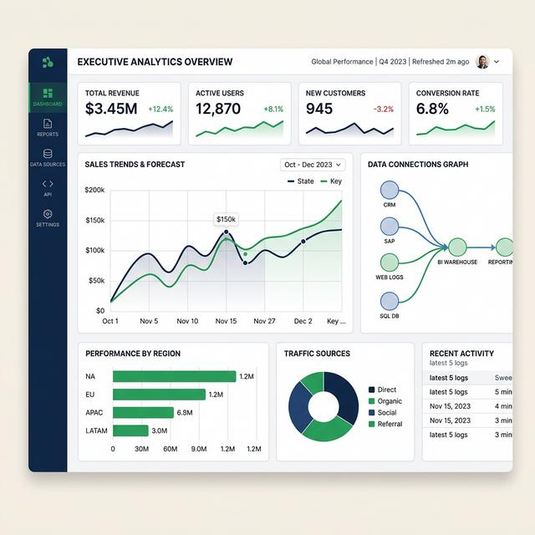
Business Intelligence (BI) Dashboard is the main screen where business users monitor company performance.
It combines all important metrics in one place.
Typical KPIs include:
- Total Revenue
- Total Orders
- Total Vendors
- Active Customers
- Top Products
- Sales by Region
- Inventory Status
- Customer Growth
Example
Revenue

$2.4M

Orders

25,340

Vendors

520

Products

18,450

Customer Growth

+18%

Inventory Alerts

23

Managers can quickly identify trends and make better business decisions without reading raw tables.

Overall Workflow of ShopSense
Vendor Registers
│
▼
Vendor Uploads Products
│
▼
Customers Purchase Products
│
▼
Orders Stored in PostgreSQL
│
▼
ETL Pipeline Cleans Data
│
▼
Machine Learning Models Analyze Data
│
▼
MLflow Tracks Model Versions
│
▼
FastAPI Serves Analytics
│
▼
BI Dashboard Displays Insights
│
▼
Docker Deploys the Platform
│
▼
GitHub Actions Automates Testing & Deployment

This progression helps students see how each technology fits into the complete ShopSense Multi-Vendor E-Commerce Analytics Platform, from vendor onboarding through analytics, machine learning, and deployment.

